St. John United Church of Christ
“In Christ We Live, Celebrate, & Serve”

December 19, 2021 | Fourth Sunday of Advent (C)
Rev. Karla Frost, Pastor | Ritch Alexander, Organist
9:30 Zoom & In-Person Worship | 9:30 Sunday School for Children
2901 Nameoki Road | Granite City, IL 62040
E-stjohnucc2901gc@yahoo.com | (618) 877-6060
Web-stjohnuccgranitecity.com
Currently face masks are REQUIRED for all.
Large print bulletins are available from the Ushers.
Bold italic denotes congregation reads or sings.
*Denotes all who are able, please stand.

WE COME TO WORSHIP GOD

PRE-SERVICE MUSIC, WELCOME AND ANNOUNCEMENTS

BELLS CALLING TO WORSHIP

PRELUDE AND CENTERING OUR HEARTS ON WORSHIP
A Christmas Medley Fischer

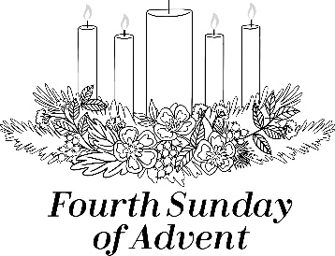

ADVENT CANDLE LIGHTING¹

READINGS BY PASTOR AND LITURGIST

UNISON PRAYER
This Advent, we wait for the birth of the Christ-Child, the Prince of Peace. And we wait for Jesus’ coming again in glory when swords will become plowshares. We pray for those who live in conflict, that they will be protected. We pray for the situations that create conflict, that they will be resolved peacefully. We pray especially for the
children, who are hurt most by conflict; protect them and bring caring adults alongside them to care for them.
-2-
Show us how we can be peacemakers in our own relationships, our own families and workplaces, and in the world. Help us to be blessed as peacemakers in your name, Amen.

SONG Light a Candle Bright and Tall Verse 4
Light a candle bright and tall
For a Love which knows no end.
Love that comes to one and all.
Fear and hatred to upend.
Shine within our hearts today
Come, O Love, to us, we pray.

CALL TO WORSHIP AND PRAYER From Hymn #174
On this 4th Sunday of Advent, there’s last minute tasks aplenty.
Prepare the way of the Lord.
And all people will see the salvation of our God.
Mall parking lots are full; grocery store shelves are empty.
Prepare the way of the Lord.
And all people will see the salvation of our God.
Airports and highways, congested; Christmas cards bring delight.
Prepare the way of the Lord.
And all people will see the salvation of our God.
Theater and arena seats rock; crowds view holiday lights.
Prepare the way of the Lord.
And all people will see the salvation of our God.
And on this fourth Sunday of Advent,
we pause and take time to worship. Let us pray together.
We have heard the call to worship in peace, O God. Help us look outside the stress and busy-ness, to see the inner gifts of peace and love. Help us believe that there is hope where we have not seen love, and that there is righteousness where we have not seen justice. Help us, like Mary and Elizabeth, believe what we have not seen, and prepare our hearts to welcome your promised salvation with joy. Amen.

*HYMN “O Little Town of Bethlehem” #180

*ADVENT AFFIRMATION OF FAITH
(Adapted from John 1 and the Nicene Creed)
-3-
In the beginning was the Word, and the Word was with God, and the Word was God. All things came into being through him, and without him not one thing was created. The life that was in him became light for all people. The light shines in the darkness, and the darkness has not overcome it.
We believe in the one Lord, Jesus Christ, the only Son of God, eternally begotten of the Father, God from God, Light from Light, true God from true God, begotten, not made, of one Being with the Father; through him all things were made.
Let your light shine in us and through us. O Child of Bethlehem, come to us. Amen.

THE SACRAMENT OF HOLY BAPTISM (pg. 10)

WE HEAR GOD’S WORD

HEBREW SCRIPTURE READING Zephaniah 3:14-20 pg. 826

ANTHEM Holiday Favorites Ritch Alexander

GOSPEL LESSON Luke 1:39-55 pg. 53

REFLECTION

WE RESPOND TO GOD’S WORD

*HYMN “Mary, Did You Know?” #192

PRAYERS OF THE PEOPLE & UNISON LORD’S PRAYER
Our Father, who art in heaven, hallowed be thy name. Thy kingdom come; thy will be done on earth as it is in
heaven. Give us this day our daily bread, and forgive us our debts as we forgive our debtors; and lead us not into temptation, but deliver us from evil; for thine is the kingdom and the power, and the glory forever. Amen.

STEWARDSHIP INVITATION

OFFERTORY Carol for Quiet Stops Johnson

*RESPONSE “O Come, O Come, Emmanuel” Vs. 4 #154
O come, Desire of nations, bind
all peoples in one heart and mind;
-4-
bid envy, strife and quarrels cease;
fill the whole world with heaven’s peace.
Rejoice! Rejoice! Emmanuel
Shall come to thee, O Israel!

UNISON PRAYER OF DEDICATION
Holy One, we pray that our offerings may fill the hungry with good things, both physically and spiritually. We rejoice to share your love, and we thank you for inspiring us to do great things, as we serve in the name of Jesus, the Prince of Peace, and your gift of Love for the world. Amen.

*HYMN “Hark! The Herald Angels Sing” #185

*BENEDICTION

*POSTLUDE A Song for the Trumpet Paxton

¹http://storage.cloversites.com/imagodeichristiancommunityhawaii/documents/Advent_Candle_Readings-2011.pdf
Song Copyright © 2012 by David Wood. All rights reserved. Written for the congregation of First United Church, Bloomington, Indiana. Permission is given for duplication and use within worship settings.

Welcome to St. John United Church of Christ on this fourth Sunday of Advent. In worship, Christian education, fellowship and service, we continue to look toward the coming of our Lord Jesus Christ.

The bulletin is given in loving memory of our parents Clyde & Dorothy Totten by Robin and Steve Totten.

The altar centerpiece is given in loving memory of her mother, Ethel Holtzscher on her Birthday, December 18th, by Jack & Sandy Dawson.

If you would like to place flowers on the altar, and pick them up Monday, please call Patty Bade at 618-610-0350. If you would like to sponsor the bulletins, please call the church office at 877-6060.

Thank you to Karen Gaines for serving as liturgist today and to Ritch Alexander for providing special music.

THIS WEEK
Today: In-person and Zoom Worship, 9:30 a.m.
Sunday School for Children, 9:30 a.m.
Baptism, 9:30 a.m.
Fellowship Hour Sponsored by Evening Guild
-5-
Fellowship Hall Reserved 12:00-8:00 p.m.
Monday: Al-Anon, 9:30-11:00 a.m.
Tuesday: Quilters, 8:30 a.m.
Bible Study, 12:30 p.m.
Wednesday: TOPS, 9:00-11:00 a.m.
Thursday: Poinsettias Delivered and Decorating
Friday: Christmas Eve, OFFICE CLOSES AT NOON
Candlelight Worship, 11:00 p.m.
Saturday: Christmas Day
Next Sunday: In-person and Zoom Worship, 9:30 a.m.
Sunday School for Children, 9:30 a.m.
Game Night, 6:00-8:00 p.m.

We extend our Christian sympathy to the family of Rose Marie Bauer, who passed from this life on Tuesday, December 14, 2021. May the peace and comfort that come from God sustain her loved ones during this time of grief.

SCRIP (GIFT CARDS)
Thank you to all who ordered gift cards through the scrip program. Because of YOUR support, the 2021 calendar-year contribution to the general fund was $418.80. This is only a drop in the bucket when you analyze the entire year’s budget, however, even small amounts make a difference! No further orders this year and taking a break for the month of January. Plans are to resume the program in February with orders submitted to the vendor company the third Sunday of each month.

MISSION OF THE MONTH
In Advent, which began November 28, we are again using TWIGS Advent Calendars and collecting specified food items for the take-home bags for children in the area.
We are again collecting baby gifts for the Church Women United layette program. Gifts may be brought throughout December and placed under the Christmas tree.
December is also the month for the annual UCC Veterans of the Cross-Christmas Fund special offering. This offering is used through the national setting of the UCC Pension Board to assist retired clergy and spouses with very low pensions, as well as lay workers and those with
-6-
special emergency needs in individual circumstances. Special envelopes were attached to the Herald and are available in the pews for this offering. Please put your regular offering envelope number on the Christmas Fund envelopes to help our counters give proper credit.
Thank you for your heartfelt mission donations to serve God’s beloved family.

In January, our Mission of the Month will be designated for UCC Disaster Ministries. These donations will be used to provide housing, food and meals, and family needs for those who were affected by the storms that caused devastation in parts of the Midwest on December 10, 2021.

CHRISTMAS EVE CANDLELIGHT WORSHIP
This year, we will offer a Christmas Eve Candlelight worship service which will begin with pre-service organ music. The lighting of the Christ Candle will occur at 11:00 p.m. and we will close with the traditional candlelight Silent Night.

OUR PRAYERS
Nursing & Assisted Living
Cedarhurst of Edwardsville, 7108 Marine Road, Edwardsville, IL 62025
Carol Hildebrand, Room B18
Cedarhurst of Granite City, Memory Care, 3432 Village Lane, Granite City, IL 62040
JoAnn King, #215,
The Fountains of West County, 15826 Clayton Rd, Ellisville, MO 63011
Ruth Buer, #215
Granite Nursing & Rehab, 3500 Century Dr, Granite City, IL 62040
Karen Luddeke
Meridian Village, 27 Auerbach Pl., Glen Carbon, IL 62034
Mary Lee Krohne, #611 (Call Linda Nitchman for updates)
Villas of Holly Brook, 121 S. Bluff Rd, Collinsville, IL 62234
Hilde Few, #208
At Home
Ritch Alexander, 2243 Cleveland, G.C., IL 62040
Isabella Boyer, 4722 S. Hazel, Edwardsville, IL 62025
-7-
Marlene Brokaw, 112 Summit Rdg., Maryville, IL 62062
Myra Cook, 4034 Stearns Ave., G.C., IL 62040
Randy Fischer, 2517 Edison Ave., G.C., IL 62040
Bonnie Fornaszewski, 200 Carlson Ave., Apt. 17D, Washington, IL 61571
Mary Franz, 3117 Willow Ave., G.C., IL 62040
Lou Hasse, 2689 Westmoreland Dr. Unit 2, G.C., IL 62040
Norman Hente, 3708 Joyce St., G.C., IL 62040
Bill McAmish, 3320 Colgate Pl., G.C., IL 62040
Sandy Mueller, 308 Warson Ln., G.C., IL 62040
David Oliver Jr., 2716 Dale Ave., G.C., IL 62040
Cliff Robertson, 2336 O’Hare Ave., G.C., IL 62040
Merle Rose, 2447 Waterman Ave., G.C., IL 62040
Marge Schmidt, 4857 Danielle Court, G.C., IL 62040
June Stille, 49 Riviera, G.C., IL 62040
Janice Weeks, 2650 Iowa, G.C., IL 62040
Don Young, 112 Summit Rdg., Maryville, IL 62062
Illinois South Conference
Brighton St. John’s UCC. Cahokia Bethel UCC, Pastor Karen Pepmeier. Retired Pastor, Rev. Paul Thompson, Jr., Red Bud, IL.

Please pray for the people who are dealing with tornado damage and the loss of family and friends.

SCRIPTURE READINGS
Zephaniah 3:14-20
¹⁴ Sing aloud, O daughter Zion; shout, O Israel! Rejoice and exult with all your heart, O daughter Jerusalem! ¹⁵ The Lord has taken away the judgments against you, he has turned away your enemies. The king of Israel, the Lord, is in your midst; you shall fear disaster no more. ¹⁶ On that day it shall be said to Jerusalem: Do not fear, O Zion; do not let your hands grow weak. ¹⁷ The Lord, your God, is in your midst, a warrior who gives victory; he will rejoice over you with gladness, he will renew you in his love; he will exult over you with loud singing ¹⁸ as on a day of festival. I will remove disaster from you, so that you will not bear reproach for it. ¹⁹ I will deal with all your oppressors at that time. And I will save the lame and gather the outcast, and I will change their shame into praise and renown in all the earth. ²⁰ At that time I will bring you home, at the time when I gather you; for I will make you renowned and praised among all the peoples of the earth, when I restore your fortunes before your eyes, says the Lord.
Luke 1:39-55
³⁹ In those days Mary set out and went with haste to a Judean town in the hill country, ⁴⁰ where she entered the house of Zechariah and
-8-
greeted Elizabeth. ⁴¹ When Elizabeth heard Mary’s greeting, the child leaped in her womb. And Elizabeth was filled with the Holy Spirit ⁴² and exclaimed with a loud cry, “Blessed are you among women, and blessed is the fruit of your womb. ⁴³ And why has this happened to me, that the mother of my Lord comes to me? ⁴⁴ For as soon as I heard the sound of your greeting, the child in my womb leaped for joy. ⁴⁵ And blessed is she who believed that there would be a fulfillment of what was spoken to her by the Lord.” ⁴⁶ And Mary said, “My soul magnifies the Lord, ⁴⁷and my spirit rejoices in God my Savior, ⁴⁸ for he has looked with favor on the lowliness of his servant. Surely, from now on all generations will call me blessed; ⁴⁹ for the Mighty One has done great things for me, and holy is his name. ⁵⁰ His mercy is for those who fear him from generation to generation. ⁵¹ He has shown strength with his arm; he has scattered the proud in the thoughts of their hearts. ⁵² He has brought down the powerful from their thrones, and lifted up the lowly; ⁵³ he has filled the hungry with good things, and sent the rich away empty. ⁵⁴ He has
helped his servant Israel, in remembrance of his mercy, ⁵⁵ according to the promise he made to our ancestors, to Abraham and to his descendants forever.”

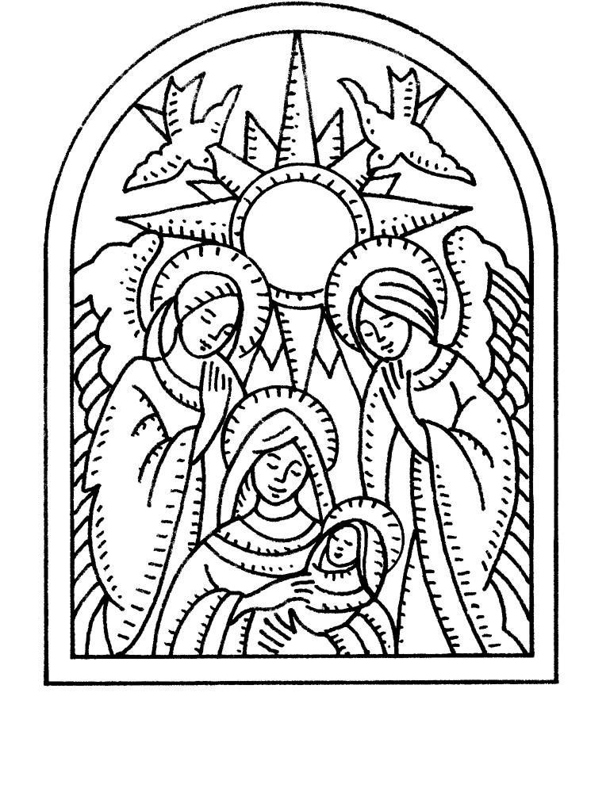
-9-
CALL FOR INFORMATION
Bell Choir – Talk to Kathy Morris, 618-210-6095
Cemetery - Talk to Kathy Montgomery, 618-876-5811
Chancel Choir – Talk to Ritch Alexander, 618-451-5092
Council – Talk to Karen Orr, President, 618-558-4192
Caslyn Brandes, Vice-President, 618-802-1152
Dine to Donate – Talk to Bev Meyer, 618-451-6849
Evening Guild – Talk to Christie Roth, 618-931-6194
Financial Reports – Talk to Mike Seibold, Treasurer, 618-792-4301
Angela Potter, 618-877-6060 church office
Heavenly Stars – Talk to Betty Meszaros, 618-451-1968
Karen Gaines, 618-288-0845
Herald – Talk to Angela Potter 618-877-6060 church office
Hilltoppers – Talk to Dee Roethemeyer, 618-876-6860
Historian – Talk to Sandy Dawson, 618-931-3467
Men’s Brotherhood – Talk to Chuck Hasse, 618-876-0936,
Dave Douglas, 618-452-3336
Quilters – Talk to Sandy Dawson 618-931-3467
Doris Peterson 618-877-1606
Sausage Dinner – Talk to Donna Brandes, 618-802-1072
Nancy Jacobs, 618-931-0673
Scrip Orders – Talk to Melissa Lane, 314-575-7627 or Betty Meszaros 618-451-1968
Sunday School – Talk to Donna Brandes, 618-802-1072
Youth Fellowship – Talk to Sharon O’Toole, 618-797-1802

Congratulations and Thanks to our newly elected 2022 Council officers!

President – Caslyn Brandes
Vice President – Kiki Cochran
Secretary – Amy Alsop
Treasurer – Mike Seibold

-10-

THE SACRAMENT OF HOLY BAPTISM

INVITATION TO THE SACRAMENT
Child: Alexandra Emily Anna Hadley
Date of Birth: March 23, 2020
Parents: Johnathon Jess Hadley & Natalie Jean Vaughn
Sponsors: Jeff Bladdick, Kelly Hadley, and Emily Svezia.

PROMISES OF THE FAMILIES AND CONGREGATION
Jesus Christ calls us to make disciples of all nations and to offer them the gift of grace in baptism. Do you who witness and celebrate this sacrament promise your love, support, and care to the one about to be baptized and to all God’s family as they live and grow in Christ?
We promise our love, support, and care.

AFFIRMATION OF FAITH Apostles’ Creed, Adapted
Let us unite with the church in all times and places in confessing our faith in the triune God.
I believe in God the Father Almighty, Maker of heaven and earth: And in Jesus Christ his only begotten Son, our Lord; who was conceived by the Holy Spirit, born of the Virgin Mary, suffered under Pontius Pilate, was crucified, dead and buried; He descended into hell; the third day he rose again from the dead; he ascended into heaven, and sitteth on the right hand of God the Father Almighty; from thence he shall come to judge the quick and the dead.
I believe in the Holy Spirit; the one Holy Universal Christian Church; the communion of saints; the forgiveness of sins; the resurrection of the body; and the life everlasting. Amen.

PRAYER, BAPTISM, AND PRESENTATION

SONG PLAYED Alley Cat

“O Little Town of Bethlehem”
O little town of Bethlehem,
How still we see thee lie!
Above thy deep and dreamless sleep
The silent stars go by.
Yet in thy dark streets shineth
The everlasting Light;
The hopes and fears of all the years
Are met in thee tonight.

For Christ is born of Mary,
And gathered all above,
While mortals sleep, the angels keep
Their watch of wondering love,
O morning stars, together
Proclaim the holy birth,
And praises sing to God the King,
And peace to all on earth.

How silently, how silently
The wondrous gift is given!
So God imparts to human hearts
The blessings of his heaven.
No ear may hear his coming,
But in this world of sin,
Where meek souls will receive him still
The dear Christ enters in.

O holy Child of Bethlehem,
Descend to us, we pray;
Cast out our sin, and enter in;
Be born in us today.
We hear the Christmas angels
The great glad tidings tell;
O come to us, abide with us,
Our Lord Emmanuel.

“Mary, Did You Know?”
Words: Mark Lowry. Music: Buddy Greene; arr. Jack Schrader. Words and Music © 1991 Word Music and Rufus Music (Admin. Gather Copyright Management) Reprinted by permission. CCLI License #1334401
Mary, did you know that your baby boy
Would someday walk on water?
Mary, did you know that your baby boy
Would save our sons and daughters?
Did you know that your baby boy
Has come to make you new?
This child that you delivered
Will soon deliver you.

Mary, did you know that your baby boy
Would give sight to a blind man?
Mary, did you know that your baby boy
Would calm a storm with his hand?
Did you know that your baby boy
Has walked where angels trod?
When you kissed your little baby,
Then you kissed the face of God.

The blind will see, the deaf will hear,
The dead will live again;
The lame will leap, the dumb will speak
The praises of the Lamb.

Mary, did you know that your baby boy
Is Lord of all creation?
Mary, did you know that your baby boy
Will one day rule the nations?
Did you know that your baby boy
Was heaven’s perfect Lamb?
This sleeping child you’re holding
Is the great “I AM!”
“Hark! The Herald Angels Sing”
Hark! The herald angels sing,
“Glory to the newborn King:
Peace on earth, and mercy mild
God and sinners reconciled!”
Joyful, all ye nations rise,
Join the triumph of the skies;
With th’angelic host proclaim,
“Christ is born in Bethlehem!”
Hark! The herald angels sing,
“Glory to the newborn King.”

Christ, by highest heaven adored,
Christ, the everlasting Lord,
Late in time behold him come,
Offspring of the Virgin’s womb:
Veiled in flesh the Godhead see;
Hail th’incarnate Deity,
Pleased with us in flesh to dwell,
Jesus, our Emmanuel.
Hark! The herald angels sing,
“Glory to the newborn King.”

Hail the heaven born Prince of Peace!
Hail the Sun of Righteousness!
Light and life to all he brings,
Risen with healing in his wings.
Mild he lays his glory by,
Born that we no more may die,
Born to raise us from the earth,
Born to give us second birth.
Hark! The herald angels sing,
“Glory to the newborn King.”

