St. John United Church of Christ
“In Christ We Live, Celebrate, & Serve”

October 22, 2023 | 21st Sunday after Pentecost (A)
Rev. Karla Frost, Pastor | Dave Ekstrand, Dir. Of Music
9:30 Zoom & In-Person Worship | 9:30 Sunday School for Children
2901 Nameoki Road | Granite City, IL 62040
E-stjohnucc2901gc@yahoo.com  Web-stjohnuccgranitecity.com | (618) 877-6060  Instagram: @stjohnucc2901gc
YouTube: gcstjohnucc Facebook: Search St. John UCC Granite City
Large print bulletins are available from the Ushers.
Bold italic denotes congregation reads or sings.
*Denotes all who are able, please stand.

WE COME TO WORSHIP GOD

PRE-SERVICE MUSIC AND BELLS CALLING TO WORSHIP

WELCOME AND ANNOUNCEMENTS

*GREETING ONE ANOTHER WITH A WAVE

*SUNG RESPONSE
Jesus loves me—this I know,
For the Bible tells me so;
Little ones to Him belong—
They are weak, but He is strong.
Yes, Jesus loves me,
Yes, Jesus loves me,
Yes, Jesus loves me—
The Bible tells me so!

A STORY FOR ALL GOD’S CHILDREN
God's love endures forever. (Psalms 136: 1a)

CENTERING THOUGHT
May we learn to listen to you with all our hearts knowing that no one could love us more.

PRELUDE AND CENTERING OUR HEARTS ON WORSHIP
Toccata in D Minor Bach

CALL TO WORSHIP AND PRAYER¹ From the hymn
As a Fire is Meant for Burning by Ruth Duck
-2-
As a fire is meant for burning with a bright and warming flame,
So the church is meant for mission,
giving glory to God’s name.
Not to preach our creeds or customs,
but to build a bridge of care,
We join hands across the nations,
finding neighbors everywhere.
We are learners; we are teachers; we are pilgrims on the way.
We are seekers; we are givers;
we are vessels made of clay.
By our gentle loving actions, we would show that Christ is light.
In a humble, listening spirit,
we would live to God’s delight.
As a green bud in the springtime is a sign of life renewed,
So may we be signs of oneness
mid earth’s peoples many hued.
As a rainbow lights the heavens when a storm is past and gone,
May our lives reflect the radiance
of God’s new and glorious dawn.
Let us pray:
Gracious Lord, the world is in need right now. Help us to appreciate each other’s differences rather than judging our diversity. Lead us to join hands and cross the bridge of caring together, knowing that just like brothers and sisters, we are all being nourished and transformed by the grace of God which you so freely give to all.
God is good. God made us and loves us. God is with us. We are with each other. Help us to understand your deep love for all people and to spread it from person to person and nation to nation. Amen

*HYMN “Here I am Lord” #559

*RESPONSIVE READING² From the hymn
Lord, You Give the Great Commission by Jeffrey Rowthorn
Lord, you give the great commission:
“Heal the sick and preach the word.”
Lest the Church neglect its mission
and the Gospel go unheard,
Help us witness to your purpose
With renewed integrity;
-3-
With the Spirit’s gifts empower us
for the work of ministry.
Lord, you call us to your service:
“In my name baptize and teach.”
That the world may trust your promise,
Life abundant meant for each,
Give us all new fervor,
Draw us closer in community;
With the Spirit’s gifts empower us
For the work of ministry.
Lord you show us loves’ true measure:
“Father, what they do, forgive.”
Yet we hoard as private treasure
All that you so freely give.
May your care and mercy lead us
To a just society;
With the Spirit’s gifts empower us
For the work of ministry.
Lord, you bless with words assuring:
“I am with you to the end.”
Faith and hope and love restoring,
May we serve as you intend,
And, amid the cares that claim us,
hold in mind eternity;
With the Spirit’s gifts empower us
for the work of ministry.
Amen.

WE HEAR GOD’S WORD

SCRIPTURE READINGS OF LOVE

SPECIAL MUSIC “Old Time Religion Medley” Spirituals
Chancel Choir

SCRIPTURE READINGS OF SERVICE

REFLECTION

WE RESPOND TO GOD’S WORD

*HYMN “We Are the Church” #550
-4-
PASTORAL PRAYER & UNISON LORD’S PRAYER
Our Father, who art in heaven, hallowed be thy name. Thy kingdom come; thy will be done on earth as it is in
heaven. Give us this day our daily bread, and forgive us our debts as we forgive our debtors; and lead us not into
temptation, but deliver us from evil; for thine is the kingdom and the power, and the glory forever. Amen.

STEWARDSHIP INVITATION

RECORDED OFFERTORY Do Something Matthew West

*SUNG RESPONSE³ “For the Life That You Have Given”
#684
For the life that You have given
For the love in Christ made known,
With these fruits of time and labor,
With the gifts that are Your own:
Here we offer, Lord. our praises;
Heart and mind and strength we bring;
Give us grace to love and serve you,
Living what we pray and sing.

*UNISON PRAYER OF DEDICATION
In our humanity, we sometimes become set in our ways. In our fear we can be reluctant to break out of familiar routines. In our complacency, we are not always willing to try new things. God, for all the times when we have cut off your dreams and hopes for us, we are truly sorry. Show us how to be a blessing to others so that we may fulfill your visions of growing the church, serving the community, and worshipping our Lord and Savior. Amen.

*HYMN “Christ, You Call Us All to Service” #571

*BENEDICTION

*POSTLUDE How Firm a Foundation Rippon

Portions of the prayers taken from “The Beautiful Word Devotional” (Zondervan 2017).

-5-
Inspiration for the Reflection from St. John UCC – Collinsville Mosaic Service and biblestudytools.com/topical-verses.
¹Words © 1992 GIA Publications. Reprinted by permission, CCLI License #1334401.
²Words © 1978 Hope Publishing Company. Reprinted by permission, CCLI License #1334401.
³Words © 1990 Hope Publishing Company. Reprinted by permission, CCLI License #1334401

“To the church of St. John United Church of Christ, in God the Father and the Lord Jesus Christ: Grace to you and peace” (see 1 Thessalonians 1:1). Welcome.

The bulletin is given in remembrance of the October birthdays of Gene & Mary Rita Ahlers, parents of Jim Ahlers by Connie & Jim Ahlers.

The altar centerpiece is given in memory of my mother, Myrtle Gee’s, birthday on October 18th and in honor of Mina McBrian’s birthday on October 14th by Leroy & Diana Schaefer.

The altar vases from the October 15th service were given in loving memory of our parents & grandparents, Leonard & Augusta Ohm, by Kara, Aaron, Genny, and Drew Wright.

If you would like to place flowers on the altar, and pick them up after church or on Monday, please call Rosalie Watson (618-741-2979). Flower Emporium offers $25 (small), $30 (medium), or $35 (large) arrangements. If you would like to sponsor the bulletins, please call the church office at (618) 877-6060. The next available date to sponsor the bulletin is October 29th.

Thank you to Karen Gaines and Connie Ahlers for preparing and leading worship today, and to Justin Gibson for serving as Greeter.

THANK YOU
I want to sincerely thank everyone for the beautiful 98th birthday cards, phone calls, and visits. You made it an awesome event. Love and Prayers, Mina McBrian
Kathy Montgomery and the cemetery staff ask for volunteers this Wednesday, October 25, at the Maryville Road site to help put together the Cremains Garden gazebo. If you have those skills to offer, call the cemetery office at 618-876-5811 for details on time and possible tools.
-6-
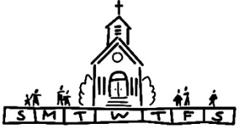
THIS WEEK
Today: Connie Ahlers & Karen Gaines Leading Worship
In-person and Zoom Worship, 9:30 a.m.
Sunday School for Children, 9:30 a.m.
Monday: Meat Sale Order Deadline
Al-Anon, 9:30 a.m.
Tuesday: Quilters, 8:30 a.m.
Bible Study, 12:30 p.m.
Wednesday: TOPS, 9:00 a.m.
Bell Choir, 5:30 p.m.
Chancel Choir, 6:30 p.m.
Thursday: Church Women United, 9:30 a.m.
Daisy Troop, 6:15-7:30 p.m.
GCC Band Rehearsal, 6:15-9:45 p.m.
Next Sunday: In-person and Zoom Worship, 9:30 a.m.
Sunday School for Children, 9:30 a.m.
5th Sunday Cash Plate
Trunk or Treat, 2:00-4:00 p.m.
Game Night, 6:00-8:00 p.m.

OCTOBER MISSION OF THE MONTH: NEIGHBORS IN NEED
Today, we begin collecting the Neighbors in Need offering. Offering envelopes can be found on the table in the Narthex and were in the October edition of the Herald. In 2023, the Neighbors in Need “BEHOLD!” theme continues. This year’s focus is on environmental impact. Plastics, electronics, and other non-compostable wastes are being shipped across, and even tossed into, our waterways, launched into space, as well as buried in landfills. As people of faith, we believe these acts are harmful to creation. We must be better stewards of our planet!

CELEBRATE THE CARDINALS
No World Series for the 2023 Saint Louis Cardinals but what a year! Adam Wainwright’s historic 200th game winner, Jordan Walker’s rookie year in the big leagues, unbelievable defensive plays –– all captured in beautiful photographs. Many of these memories will be included in the Cardinals official 2024 calendar. The calendar measures 17” by 15” and includes the 2024 game schedule. Orders will be taken until November 12th with delivery in time for Christmas gift-giving. Cost of the calendar
-7-
will be the same $17 as last year. Each order also entitles the purchaser to one entry for the “Celebrate the Cardinals” gift basket. Basket includes two $20 gift certificates to Ravanelli‘s Steakhouse, book on history of Sportsman’s Park, Yadi Molina photo on wooden plaque and replica jersey plus so much more! Additional chances may be purchased $1 each or six for $5. Chances may also be purchased if no calendar order. Proceeds to benefit St. John Cemetery projects. Betty Meszaros will be in Fellowship Hall after worship services with order forms and raffle tickets or call the cemetery office at 618-876-5811 if questions.
TRUNK-OR-TREAT
It is that time of year again when spooky things are all around us. The St. John Youth Group along with the Christian Education Group will be sponsoring the 2nd Annual Trunk-Or-Treat on Sunday, October 29, 2023 from 2:00-4:00 p.m. This event will take place rain or shine in the church parking lot. Listed below are three things we need to make this event a success.
- Trunks - We need volunteers to fill the parking lot with Halloween decorated vehicles. Let’s spruce up our trunks and/or truck beds with crepe paper and pumpkins and fill them with treats for the kids. While you are decorating your vehicle, remember to dress up yourself! Costumes are encouraged for everyone!
- Treats - While those decorating their cars will bring treats for the kids, we will also need candy for game prizes and to shore up any shortages. Don’t want to donate candy? We will take other treats as well, such as spider rings, vampire teeth, spooky stickers, etc. Please bring donations anytime before October 29th and drop off in the church office.
- Helpers - Don’t feel like cleaning out the trunk or bed of your vehicle? That is ok. We can use you at the games. We intend to have various games set up and are looking for volunteers to supervise. Again, this is a great chance to bring out your capes and wigs to participate in the fun by dressing up!
New this year we will have at least 2 food trucks along with some spooky music playing. To volunteer in any capacity, please contact:
Sharon O’Toole - 314-420-1548
sharon.otoole66@gmail.com
Donna Brandes - 618-802-1072
donnabrandes@yahoo.com
-8-
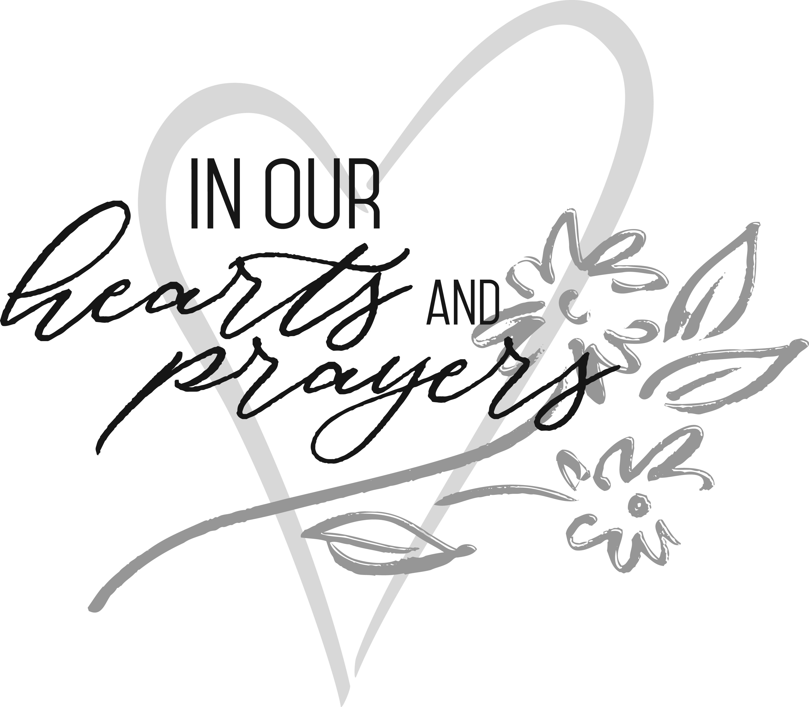
OUR PRAYERS
Hospital
Nursing, Assisted, & Independent Living
Bob Braundmeier, Earl Buenger, Marcia Buenger, Ruth Buer, Myra Cook, Hilde Few, Bonnie Fornaszewski, JoAnn King, Karen Luddeke, and Marjorie Schmidt.
At Home
Chloe Affolter, Karen Anders, Isabella Boyer, Mary Franz, Luitgard Fries, Melba Grady, Chuck Hasse, Lou Hasse, Barbara Houston, Chuck King, Mina McBrian, Cindy Meyer, Sandy Mueller, Cliff Robertson, June Stille, Janice Weeks, and Nancy Wilson.
Illinois South Conference
Irvington Friedens UCC, Rev. Stacy (Mark) Tate. O’Fallon HSHS, Chaplain Rev. Dr. Chance (Christopher Guelbert) Beeler. Retired Pastor Rev. Kevin (Shellie) Strope, Carlinville, IL.

SCRIPTURE READINGS
Scripture Readings of Love
Let us consider how we may spur one another on towards love and good deeds. (Hebrews 10:24)
My command is this: Love each other as I have loved you. (John 15:12)
Love your neighbor as yourself. (Galatians 5:14)
Dear friends, since God so loved us, we also ought to love one another. (1 John 4:11)
These three remain: faith, hope and love. But the greatest of these is love. (1 Corinthians 13:13)
Be like-minded, be sympathetic, love one another, be compassionate and humble. (1 Peter 3:8)

Scripture Readings of Service
Do to others as you would have them do to you. (Luke 6:31)
Whatever you want others to do to you, do also to them, for this is the law and the Prophets. (Matthew 7:12)
Even the Son of Man did not come to be served, but to serve, and to give his life as a ransom for many. (Mark 12:45)

-9-
Let us not love with words or speech but with actions and in truth. (1 John 3:18)
Always give yourselves fully to the work of the Lord, because you know that your labor in the Lord is not in vain. (1 Corinthians 15:58)
There are different kinds of gifts, but the same Spirit distributes them. There are different kinds of service but the same Lord. There are different kinds of working but in all of them and in everyone it is the same God at work. (1 Corinthians 12:4-6)
Though one may be overpowered, two can defend themselves. A cord of three strands is not quickly broken. (Ecclesiastes 4:12)
Each of you should use whatever gift you have received to serve others, as faithful stewards of God’s grace in its various forms. (1 Peter 4:10)
Whatever you do, work at it with all your heart, as working for the Lord, not for human masters. (Colossians 3:23)
Give, and it will be given to you. (Luke 6:38)
What does the Lord require of you? To act justly and to love mercy and to walk humbly with your God. (Micah 6:8)
He who began a good work in you will carry it on to completion until the day of Christ Jesus. (Philippians 1:6)
The King will reply, “Truly I tell you, whatever you did for one of the least of these brothers and sisters of mine, you did for me.” (Matthew 25:40 )
Then the master told his servant, “Go out to the roads and country lanes and compel them to come in so that my house will be full”. (Luke 14:23)

Try our QR code! This little square will take you directly to our secure MyVanco website where you can contribute to any of our various funds. Just follow three simple steps:

- Open your smart phone’s camera app
- Aim the camera at the black and white square below and a link will appear on your screen.
- Click the link and you’ll be directed to our donations website. From there, you can select a fund to which you’d like to make a contribution.
Thank you!

-10-
CALL FOR INFORMATION
Bell Choir – Talk to Kathy Morris, 618-210-6095
Cemetery -- Talk to Kathy Montgomery, 618-876-5811
Chancel Choir – Talk to John Nitchman, President, 618-288-5297
Council – Talk to Kiki Cochran, President, 618-797-2511 or Donna Brandes, Vice President, 618-802-1072
Evening Guild – Talk to Christie Roth, 618-931-6194
Financial Reports – Talk to Mike Seibold, Treasurer, 618-792-4301
or 618-877-6060 church office
Heavenly Stars – Talk to Betty Meszaros, 618-451-1968
Karen Gaines, 618-288-0845
Herald – Talk to 618-877-6060 church office
Hilltoppers – Talk to Dee Roethemeyer, 618-876-6860
Historian – Talk to Sandy Dawson, 618-791-8246
Men’s Brotherhood – Talk to Chuck Hasse, 618-876-0936,
Dave Douglas, 618-452-3336
Quilters – Talk to Sandy Dawson 618-791-8246
Doris Peterson 618-877-1606
Sausage Dinner – Talk to Donna Brandes, 618-802-1072
Nancy Jacobs, 618-931-0673
Scrip Orders – Talk to Melissa Lane, 314-575-7627 or Betty Meszaros 618-451-1968
Sunday School – Talk to Donna Brandes, 618-802-1072
Youth Fellowship – Talk to Sharon O’Toole, 314-420-1548

