St. John United Church of Christ
“In Christ We Live, Celebrate, & Serve”

August 6, 2023 | 10th Sunday after Pentecost (A)
Rev. Karla Frost, Pastor | Dave Ekstrand, Dir. Of Music
9:30 Zoom & In-Person Worship | 9:30 Sunday School for Children
2901 Nameoki Road | Granite City, IL 62040
E-stjohnucc2901gc@yahoo.com  Web-stjohnuccgranitecity.com | (618) 877-6060  Instagram: @stjohnucc2901gc
YouTube: gcstjohnucc Facebook: Search St. John UCC Granite City
Large print bulletins are available from the Ushers.
Bold italic denotes congregation reads or sings.
*Denotes all who are able, please stand.

WE COME TO WORSHIP GOD

PRE-SERVICE MUSIC AND BELLS CALLING TO WORSHIP

WELCOME AND ANNOUNCEMENTS

*GREETING ONE ANOTHER “Peace be with you!”

*SUNG RESPONSE “Let There Be Peace on Earth” #614
Let there be peace on earth, and let it begin with me;
let there be peace on earth, the peace that was meant to be.
With God our creator, children all are we.
Let us walk with each other in perfect harmony.
Let peace begin with me; let this be the moment now.
With every step I take, let this be my solemn vow:
to take each moment and live each moment in peace eternally.
Let there be peace on earth, and let it begin with me.

A STORY FOR ALL GOD’S CHILDREN Romans 9:1-5
“I am speaking the truth in Christ—I am not lying; my conscience confirms it by the Holy Spirit…”

PRELUDE AND CENTERING OUR HEARTS ON WORSHIP
Toccata in E Minor Pachelbel
CENTERING THOUGHT¹
When our faith is at its weakest, God struggles with us—not to punish, but to bless us, if we have the courage to ask.

CALL TO WORSHIP AND PRAYER
-2-
Are you hungry for a word of hope?
We come to be fed and nourished.
Are you yearning to trust the power of our God?
Yes, we are.
Even when our faith falters,
We will not let go of God.
In our need for physical and spiritual food,
We will trust God.
Let us pray together.
God of wonder and mystery, you struggle with us when our faith is hesitant and meet us in our struggles. When our own needs, and the needs of the world, feel overwhelming, you stay with us. Especially in this time of worship today, fill us with the Holy Spirit to meet our hunger, and send us out as faithful disciples, in Jesus’ name. Amen.

*HYMN “God of Grace and God of Glory” #569

*LITURGY OF CONFESSION AND PARDON²
All of us need times of wrestling with God over issues in our lives. These moments of confession offer us one such opportunity. Bring your own distress to this time of confessing the sin in which all of us have a part.
God of justice and righteousness, whose compassion for humankind was expressed so vividly in Jesus, we bring to you our sorrow and anguish that we have not followed faithfully in the footsteps of Christ. Unkindness and deceit are all around us, and we have sometimes joined in their destructive ways. We waste resources you have entrusted to us. We cause others to stumble and fall. Take away our wickedness, O God, and restore your peace among us, we pray in Jesus name. Amen.
God is merciful, patient, kind, and loving. All creation is subject to God’s care and concern. In Christ, our brokenness finds healing, and relationships are mended and strengthened. Know the glory of God, and know peace.

WE HEAR GOD’S WORD

HEBREW SCRIPTURE LESSON Genesis 32:22-31 pg. 29
-3-
SPECIAL MUSIC The Old Rugged Cross arr. Price

GOSPEL LESSON Matthew 14:13-21 pg. 15

REFLECTION

WE RESPOND TO GOD’S WORD

*HYMN “Break Now the Bread of Life” #665

PASTORAL PRAYER

RESPONSE “The Lord’s Prayer” (One Amen) #740

THE SACRAMENT OF HOLY COMMUNION

STEWARDSHIP INVITATION

OFFERTORY God, We Praise You arr. Smith

*SUNG RESPONSE “Spirit of the Living God” #492
Spirit of the living God, fall afresh on me;
Spirit of the living God, fall afresh on me.
Melt me, mold me, fill me, use me.
Spirit of the living God, fall afresh on me.

Spirit of the living God, move among us all;
make us one in heart and mind, make us one in love: humble, caring, selfless, sharing.
Spirit of the living God, fill our lives with love.

*UNISON PRAYER OF DEDICATION¹
Source of Compassion, you meet our needs. May our gifts become loaves and fish for those who hunger. May our offerings become love and light for those who feel lost and afraid. Bless our lives and our ministries, that we may be a people who share our abundance with those who live in want. In our living and in our giving, may the world be fed and made whole again. Amen.

INVITATION¹
Faced with a hungry crowd and only five loaves and two fish,
Jesus fed the multitude until all were satisfied.
Eternal God, we are hungry in body and spirit.
-4-
We are empty and long to be filled.
We are hungry and long to be fed.
We are lost and long to be found.
Heal our brokenness through the breaking of this bread and the sharing of this cup.
Then pick up the pieces of our lives, just as Jesus gathered up the fragments of bread and fish after he fed the five thousand.
Make us whole and bless us to be a blessing for others.
Amen.

COMMUNION PRAYER

BREAKING, POURING AND PARTAKING
All confessing Christians are welcome to the Sacrament of Holy Communion. Please hold each element when served in the pews so all may partake together. The inner circle of cups contains white grape juice. The outer circles have wine.

*UNISON PRAYER OF THANKSGIVING
Thank you, O God, for by your Spirit you make us one with Christ at his table, one with the heavenly hosts, one with each other in peace, and one in mission to all the world. Send us out to share the abundant love of Christ with generous joy. Amen.

*HYMN & NOISY OFFERING FOR CEMENT STEPS
“Now Let Us from This Table Rise” #715

*BENEDICTION

*POSTLUDE All Hail the Power of Jesus’ Name Prentiss

¹Adapted from The Abingdon Worship Annual 2023. Copyright © 2022 by Abingdon Press. Used by permission.

²Adapted from “Taught by Love”. Copyright © 1998 by United Church Press. Used by permission.
Through Isaiah, God calls, “Everyone who thirsts, come to the waters” (Isaiah 55:1, ESV). We come today to the Living Water made known in Jesus Christ. Welcome.

The bulletin is given in honor of Baylee Fischer’s 14th birthday by her family.

-5-
The altar vases are given in loving memory of Annette Stevenor by the St. John Sunday School.

The altar centerpiece is given in honor of Baylee Fischer’s 14th birthday today, by Grandma Pam, Mom, Dad, Conyr, and Brayden.

If you would like to place flowers on the altar, and pick them up after church or on Monday, please call Barb Houston (618-610-1884). Flower Emporium offers $25 (small), $30 (medium), or $35 (large) arrangements. If you would like to sponsor the bulletins, please call the church office at (618) 877-6060. The next available dates to sponsor the bulletin are October 15th & 29th.

Thank you to Baylee Fischer for serving as liturgist and acolyte, to Chris McMillan for serving as guest organist, and to the Fischer family for greeting.

THIS WEEK
Today: In-person and Zoom Worship, 9:30 a.m.
Sunday School for Children, 9:30 a.m.
Communion & Noisy Offering
Distribute Catch-Up Letters & Giving Statements
Scrip Orders Placed Today
Monday: Al-Anon, 9:30-11:00 a.m.
Tuesday: Quilters, 8:30 a.m.
Bible Study, 12:30 p.m.
Hilltoppers, 12:30 p.m.
Wednesday: TOPS, 9:00 a.m.
Thursday: Council Meeting, 6:00 p.m.
Next Sunday: In-person and Zoom Worship, 9:30 a.m.
Sunday School for Children, 9:30 a.m.
Trivia Planning Team after worship
Fellowship Hall Reserved for June Stille’s birthday,
1:00 p.m.

HILLTOPPERS
The next Hilltoppers meeting is Tuesday, August 8th at 12:30 p.m. The September meeting will be Tuesday, September 12th at 12:00 p.m. Everyone is asked to bring sandwiches to the September meeting.

-6-
MISSION OF THE MONTH
The August MOM is the church’s Food Box Distribution Program.

BIRTHDAY CELEBRATION!
Please join us in celebrating the 90th birthday of June Stille next Sunday, August 13th, beginning at 1:00 p.m. in the Fellowship Hall. June would love for all of her church friends to stop by and say hello and to wish her well. We are truly blessed to be celebrating this milestone with her. Your presence is the only present required. Hope to see you all! -Dan & Ruth Comer

SCRIP
Orders will be submitted TODAY! Third Sunday schedule will be resumed in September and October. Orders will be submitted second Sunday in November and December to accommodate holiday delivery schedules. Confused? You are not alone!!! Order schedules will be repeated as time grows nearer.
If you are planning to order scrip cards to donate for Trivia Night raffle or attendance prizes, please order TODAY (refer to Trivia Night announcement for more details). Orders for personal use always appreciated. Master list of vendors and St John ”favorites“ order forms are in the blue folder on the table in the Narthex. Give order form and check payable to St. John UCC to Betty Meszaros at any time. Cash is also accepted but only if giving order to Betty in person. You can still participate in the program if not attending in-person worship. Just drop off or mail your check to the church with a note of cards you are ordering. Cost is face value of the card with no tax or service fee. Rebate is automatically sent to the church. Contact Melissa Lane 314-575-7627 or Betty Meszaros 618-451-1968 questions.

On August 19, 2023 we will be having our church barbecue fundraiser. It will take place from 11:00 a.m. to 5:00 p.m. or until we sell out of items. The menu includes the following:
-7-
1lb Pork Steak & 2 Sides - $12.00
Bratwurst & 2 Sides - $12.00
¼ lb Hot Dog & 1 Side - $6.00
Side options will include Relleke Corn, baked beans, and potato salad. Desserts will also be available for an additional cost. Tickets will be available for pre-sale soon.

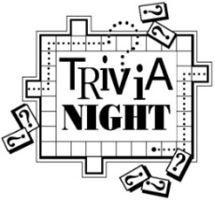
Trivia Night is back! For the first time since 2019, plans are in progress for a fun-filled Trivia Night on Saturday, August 26th. Invite family and friends. Since this is an alcohol-free event, older children are welcome IF they can be disconnected from cell phones. Cost is $120 per table if you have one or any number up to the maximum of eight players per table. First and second place prizes awarded to winning tables. Popcorn, lemonade, tea and water are included and you can bring your own food and beverages (no alcohol please).
August 6 - Scrip order submitted for “Great Gift Card Giveaway” also known as “Super Duper Gift Card basket” raffle. Rather than the traditional silent auction offered only to those attending the event, this raffle will be open to all who purchase an entry slip. The value of “basket” will be determined by amount of gift cards received. Donations appreciated from the congregation of cards purchased through the scrip program or elsewhere and in any denomination. If donating cards outside of scrip program, please give to Betty Meszaros or text her at 618-670-5267 TODAY to allow time to assemble for entry sales.
August 13 - Entry slips for the “Great Gift Card Giveaway” will be sold in fellowship hall after worship service. Total value will be announced. Charge will be $1 each, six for $5 , twelve for $10 or twenty-five for $20. Drawing will be at the August 26 Trivia Night. Winner need not be present.
August 19 - “Great Gift Card Giveaway” chances sold during the Church Barbecue.
August 23 - Deadline to register your table. Registration forms on back of inserts in bulletin. Pre-payment is appreciated but
-8-
sometimes not logistically possible so payment accepted night of the event. Contact church office at 618-877-6060 if questions.
Proceeds from event will be used to purchase new computer equipment for church office and chairs for cemetery chapel.

TRIVIA PLANNING TEAM
There will be a meeting of the Trivia Planning Team after worship on Sunday, August 13th in the All Purpose Room.

ANNUAL FALL MUM SALE
It’s time to order your mums in our Annual Fall Mum Sale! Mums are 9 inches and $12.00 each with the color choices of bronze/orange, red, white, yellow, and pink/purple. Order forms are available on the table in the Narthex. Forms are due to the church office no later than Sunday, August 27th, with estimated pick-up being either September 16th or 23rd. Payment is due at the time your order is placed. If you have any questions, please call the church office at 618-877-6060.

FOOD BOX DISTRIBUTION
On Wednesday, September 6th we will need help packing the food boxes beginning at 9:00 a.m. The distribution of those boxes will be the following Saturday, September 9th. We will also need volunteers on Saturday starting at 8:30 a.m. for set up, with distribution beginning at 10:00 a.m.

3RD GRADE BIBLE PRESENTATIONS
Any of our children entering 3rd grade next August may receive a special Bible on Sunday, September 17, during 9:30 a.m. worship. Please call the church office at 618-877-6060 to give name and address for letters to be sent inviting them to participate.

PLASTIC BOTTLE CAP COLLECTION
We are collecting plastic bottle caps to assist Eleanor Reynolds in her Girl Scout bench project. Bottle caps should be put in the tub in the Narthex.

-9-
If sorting & cleaning are in your plans, this will be the perfect time to hold aside items to donate to the all-church rummage sale. The event will be held September 28th & 29th this year and items can be brought to the stage in Fellowship Hall between September 5th and September 27th. No large electronics or heavy items please. General rule of thumb: If you would have to pay for it to be recycled, item cannot be accepted. This sale is sponsored by the Evening Guild with assistance appreciated from family and friends. All proceeds are given to church projects or local charitable organizations. Please mark the following important dates on your calendar. Volunteers are especially needed during Set Up and Pricing:
Tuesday, September 26th – 9:00 a.m. Set up
Wednesday, September 27th – 9:00 a.m.
Pricing
Thursday, September 28th – 8:30 a.m. to
3:00 p.m. Open for Shoppers
Friday, September 29th – 8:30 a.m. to 12:00
p.m. Open for Shoppers

OUR PRAYERS
Hospital, Nursing, Assisted, & Independent Living
Earl Buenger, Marcia Buenger, Ruth Buer, Myra Cook, Hilde Few, JoAnn King, Karen Luddeke, Merle Rose, Marjorie Schmidt, and Jerry Shonk.
At Home
Chloe Affolter, Isabella Boyer, Carol Braundmeier, Christopher Clark, Bonnie Fornaszewski, Mary Franz, Luitgard Fries, Melba Grady, Lou Hasse, Chuck King, Mina McBrian, Cindy Meyer, Sandy Mueller, Cliff Robertson, June Stille, Janice Weeks, and Nancy Wilson.
Illinois South Conference
Darmstadt Holy Ghost UCC, Rev. Tarrah (Jasen) Vaupel. DuBois St. Mark’s UCC. Retired Pastor, Rev. Christopher and Cathy Hill, O’Fallon, IL.

-10-
SCRIPTURE READINGS
Genesis 32:22-31
²² The same night he got up and took his two wives, his two maids, and his eleven children and crossed the ford of the Jabbok. ²³ He took them and sent them across the stream, and likewise everything that he had. ²⁴ Jacob was left alone, and a man wrestled with him until daybreak. ²⁵ When the man saw that he did not prevail against Jacob, he struck him on the hip socket, and Jacob’s hip was put out of joint as he wrestled with him. ²⁶ Then he said, “Let me go, for the day is breaking.” But Jacob said, “I will not let you go, unless you bless me.” ²⁷ So he said to him, “What is your name?” And he said, “Jacob.” ²⁸ Then the man said, “You shall no longer be called Jacob, but Israel, for you have striven with God and with humans and have prevailed.” ²⁹ Then Jacob asked him, “Please tell me your name.” But he said, “Why is it that you ask my name?” And there he blessed him. ³⁰ So Jacob called the place Peniel, saying, “For I have seen God face to face, yet my life is preserved.” ³¹ The sun rose upon him as he passed Penuel, limping because of his hip.
Matthew 14:13-21
¹³ Now when Jesus heard this, he withdrew from there in a boat to a deserted place by himself. But when the crowds heard it, they followed him on foot from the towns. ¹⁴ When he went ashore, he saw a great crowd, and he had compassion for them and cured their sick. ¹⁵ When it was evening, the disciples came to him and said, “This is a deserted place, and the hour is now late; send the crowds away so that they may go into the villages and buy food for themselves.” ¹⁶ Jesus said to them, “They need not go away; you give them something to eat.” ¹⁷ They replied, “We have nothing here but five loaves and two fish.” ¹⁸ And he said, “Bring them here to me.” ¹⁹ Then he ordered the crowds to sit down on the grass. Taking the five loaves and the two fish, he looked up to heaven and blessed and broke the loaves and gave them to the disciples, and the disciples gave them to the crowds. ²⁰ And all ate and were filled, and they took up what was left over of the broken pieces, twelve baskets full. ²¹ And those who ate were about five thousand men, besides women and children.

“God of Grace and God of Glory”
God of grace and God of glory,
On your people pour your power;
Crown your ancient Church’s story,
Bring its bud to glorious flower.
Grant us wisdom, grant us courage
For the facing of this hour,
For the facing of this hour.

Lo! The hosts of evil round us
Scorn your Christ, assail his ways!
Fears and doubts too long have bound us --
Free our hearts to work and praise.
Grant us wisdom, grant us courage
For the living of these days,
For the living of these days.

Heal your children’s warring madness,
Bend our pride to your control;
Shame our wanton, selfish gladness,
Rich in things and poor in soul.
Grant us wisdom, grant us courage
Lest we miss your kingdom’s goal,
Lest we miss your kingdom’s goal.

Save us from weak resignation
To the evils we deplore;
Let the gift of your salvation
Be our glory evermore.
Grant us wisdom, grant us courage
Serving you whom we adore,
Serving you whom we adore.

“Break Now the Bread of Life”
Break now the bread of life, dear Lord, to me,
As once you broke the loaves beside the sea.
Beyond the sacred page I seek you, Lord;
My spirit longs for you, O living Word.

Bless your own Word of truth, dear Lord, to me,
As when you blessed the bread by Galilee.
Then shall all bondage cease, all fetters fall;
And I shall find my peace, my All in all!

You are the bread of life, dear Lord, to me;
Your holy Word the truth that rescues me.
Give me to eat and live with you above;
Teach me to love your truth, for you are love.

O send your Spirit now, dear Lord, to me,
That he may touch my eyes and make me see.
Show me the truth made plain within your Word,
For in your book revealed I see the Lord.

“The Lord’s Prayer”
Our Father, who art in heaven,
Hallowed be thy name.
Thy kingdom come, thy will be done
On earth as it is in heaven.
Give us this day our daily bread,
And forgive us our debts,
As we forgive our debtors.
And lead us not into temptation
But deliver us from evil:
For thine is the kingdom,
And the power,
And the glory, forever,
Amen.

Now let Us from This Table Rise”
Words: Fred Kaan © 1968 Hope Publishing Company. Reprinted by permission, CCLI license #1334401.
Now let us from this table rise,
Renewed in body, mind, and soul;
With Christ we die and rise again,
His selfless love has made us whole.

With minds alert, upheld by grace,
To spread the Word in speech and deed,
We follow in the steps of Christ,
At one with all in hope and need.

To fill each human house with love,
It is the sacrament of care;
The work that Christ began to do
We humbly pledge ourselves to share.

Then give us grace, Companion God,
To choose again the pilgrim way;
And help us to accept with joy
The challenge of tomorrow’s day.

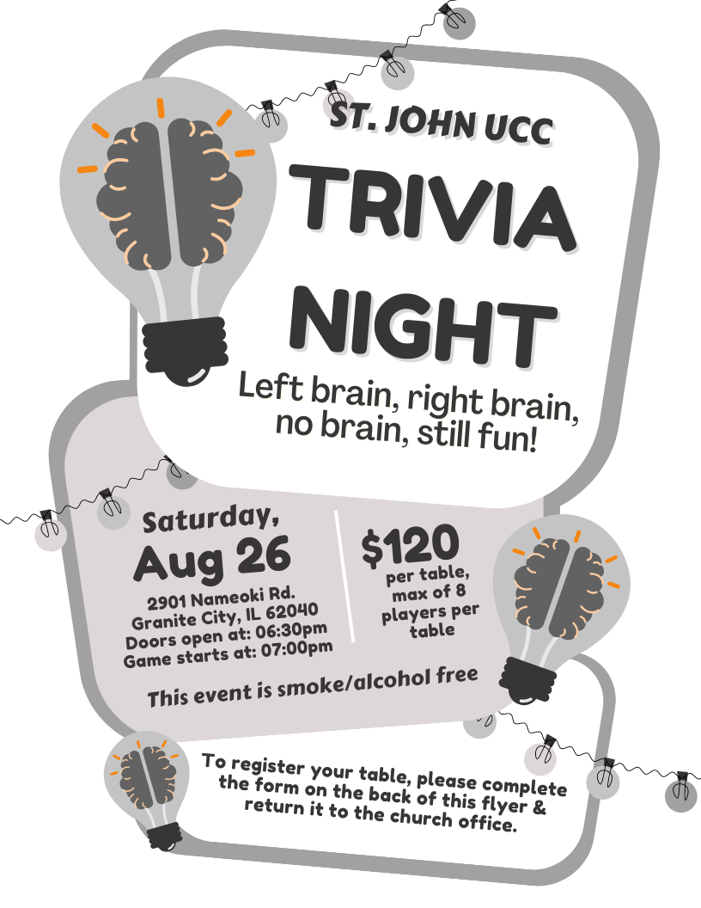

St. John UCC Trivia Night
Table Registration Form

This form is due in the church office by Wednesday, August 23rd.

You can also submit your registration by phone (call 618-877-6060) or by email (send information to stjohnuccevents@gmail.com)

CONTACT NAME _____________________________________

CONTACT PHONE NUMBER ___________________________

PAYMENT ENCLOSED (please circle one) YES NO

Doors will open at 6:30 p.m. and the game will start at 7:00 p.m. Cost is $120.00 per table, with a max of 8 players at each table. Cash Prizes will be awarded to the 1st & 2nd place tables. Prizes will also include:
- 1 Super-Duper Gift Card Basket Drawing (chances sold before August 26th and during the evening of the 26th before the drawing)
- 50/50 drawing
- 1 Attendance prize drawing per round

Popcorn, iced tea, lemonade, coffee and ice will be provided at no additional cost.

This event is smoke & alcohol free.

FOOD BOX PROJECT
On Saturday, September 9th, we will continue our church’s Food Box Give-Away Program to help fight hunger in the community. Food prices are high, as we all know, which means it will cost more to fill the boxes. To offset the costs, we are once again asking for donations of food from the congregation. Also, if anyone has any contacts for food donations, such as grocery stores, produce markets, food manufacturers, dairies, etc., please let us know. During the March distribution, we gave away 180 boxes. We are hoping to distribute at least 150 - 175 boxes.

For those who would like to donate food for this project, the following is a suggested list to follow. Dates of collection for specific items have been included. If anyone has items to donate that do not appear on the list or would like to donate them on a different Sunday than what is listed, feel free to do so. Please make sure items being donated are not expired. Both Name Brand items and store brands are acceptable items to donate. Watch for sales at Schnucks, Ruler (they send out coupons), Aldi, Walmart, Sam’s, etc. The congregation’s generosity and participation has been tremendous for this project as well as all the others that have been implemented.

Suggested donations and dates:
Sun, 6-11-23 | Canned soup (chicken noodle, vegetable, tomato, etc.) or vegetable canned goods*
Sun, 6-18-23 | Canned chili & stew*
Sun, 6-25-23 | Boxed cereal (Cheerios, Rice Krispies, Corn Flakes, avoid sugary cereals such as Froot Loops)
Sun, 7-2-23 | Peanut butter 16 oz jar (Ruler has the lowest price to date)
Sun, 7-9-23 | Jars of applesauce (The Kroger brand is inexpensive)
Sun, 7-16-23 | Canned Spaghetti Os (Campbells) or Spaghetti & Meat Balls or Lasagna (Chef Boyardee). It can be similar products under other manufacturers as well.
Sun, 7-23-23 | Canned tuna or 2lb bag of rice
Sun, 7-30-23 | 64 oz bottles of juice - apple cranberry, grape - (Dollar Tree has inexpensive options)
Sun, 8-6-23 | Mac & cheese dinners
Sun, 8-13-23 | Vegetable canned goods*
Sun, 8-20-23 | 5 lb bag of flour
Sun, 8-27-23 | Canned chili & stew*
*These items are listed twice due to the high volume needed

