St. John United Church of Christ
“In Christ We Live, Celebrate, & Serve”

July 30, 2023 | 9th Sunday after Pentecost (A)
Rev. Karla Frost, Pastor | Dave Ekstrand, Dir. Of Music
9:30 Zoom & In-Person Worship | 9:30 Sunday School for Children
2901 Nameoki Road | Granite City, IL 62040
E-stjohnucc2901gc@yahoo.com  Web-stjohnuccgranitecity.com | (618) 877-6060  Instagram: @stjohnucc2901gc
YouTube: gcstjohnucc Facebook: Search St. John UCC Granite City
Large print bulletins are available from the Ushers.
Bold italic denotes congregation reads or sings.
*Denotes all who are able, please stand.

WE COME TO WORSHIP GOD

PRE-SERVICE MUSIC AND BELLS CALLING TO WORSHIP

WELCOME AND ANNOUNCEMENTS

*GREETING ONE ANOTHER WITH A WAVE AND PEACE

*SUNG PRAISE RESPONSE “Glory Be to the Father” #734
Glory be to the Father, and to the Son,
and to the Holy Ghost;
as it was in the beginning,
is now, and ever shall be,
world without end. Amen, Amen.

A STORY FOR ALL GOD’S CHILDREN Romans 8:26-39
For I am convinced that neither death, nor life, nor angels, nor rulers, nor things present, nor things to come, nor powers, nor height, nor depth nor anything else in all creation will be able to separate us from the love of God in Christ Jesus our Lord. (Vss. 38-39)

PRELUDE AND CENTERING OUR HEARTS ON WORSHIP
Come, Let Us Praise the Lord Darwell
CENTERING THOUGHT¹
Good things come to those who wait. Like seeds buried in the ground, God’s love bursts forth in the fullness of time to bring new life and new possibilities.
-2-
CALL TO WORSHIP AND PRAYER
Cong. Response Romans 8:28
The kingdom of heaven grows in us.
We know that all things work together for good for those who love God, who are called according to his purpose.
The kingdom of heaven grows through us.
We know that all things work together for good for those who love God, who are called according to his purpose.
The kingdom of heaven is our treasure.
We know that all things work together for good for those who love God, who are called according to his purpose.
The kingdom of heaven is our treasure in new and old ways.
We know that all things work together for good for those who love God, who are called according to his purpose.
Let us pray:
God of ancient generations and new ones, we worship and praise you. We know you desire good for all our days, yet there are times of trouble. Life is not always fair; people are not always honorable. Still, you offer the most valuable gift and promise of all—that nothing can separate us from your love in Jesus our Savior. Thank you for blessing us and reminding us over and over that Jesus loves us, forever. Amen.

*HYMN “Seek Ye First” #349

*RESPONSIVE PSALTER READING Psalm 105:1-11, 45b
O give thanks to the Lord, call on his name,
make known his deeds among the peoples.
Sing to him, sing praises to him;
tell of all his wonderful works.
Glory in his holy name;
let the hearts of those who seek the Lord rejoice.
Seek the Lord and his strength;
seek his presence continually.
Remember the wonderful works he has done,
his miracles, and the judgments he uttered,
O offspring of his servant Abraham,
children of Jacob, his chosen ones.

-3-
He is the Lord our God;
his judgments are in all the earth.
He is mindful of his covenant forever,
of the word that he commanded, for a thousand generations,
The covenant that he made with Abraham,
his sworn promise to Isaac,
Which he confirmed to Jacob as a statute,
to Israel as an everlasting covenant,
Saying, “To you I will give the land of Canaan as your portion for an inheritance.”
Praise the Lord!

WE HEAR GOD’S WORD

HEBREW SCRIPTURE LESSON Genesis 29:15-28 pg. 25

SPECIAL MUSIC Jesus Loves Me Mayleigh Alsop
English and Chinese

GOSPEL LESSON Matthew 13:31-33, 44-52 pg. 14

REFLECTION

WE RESPOND TO GOD’S WORD

*HYMN “God of the Ages, History’s Maker” #78

PASTORAL PRAYER & UNISON LORD’S PRAYER
Our Father, who art in heaven, hallowed be thy name. Thy kingdom come; thy will be done on earth as it is in
heaven. Give us this day our daily bread, and forgive us our debts as we forgive our debtors; and lead us not into
temptation, but deliver us from evil; for thine is the kingdom and the power, and the glory forever. Amen.

STEWARDSHIP INVITATION, 5TH SUNDAY CASH PLATE

OFFERTORY Alleluia! Alleluia! Let the Holy Anthem Rise

*SUNG RESPONSE² “Make Me a Servant” #576
Make me a servant, humble and meek,
Lord, let me lift up those who are weak;
-4-
and may the prayer of my heart always be:
make me a servant, make me a servant,
make me a servant today.

*UNISON PRAYER OF DEDICATION
We have brought these gifts from our treasure, O Lord, and given them for the work of your kingdom. May they increase in value as they do good for all, in your name. Amen.

*HYMN “All the Way My Savior Leads Me” #505

*BENEDICTION

*POSTLUDE Hope of the World Harkness

¹Adapted from The Abingdon Worship Annual 2023. Copyright © 2022 by Abingdon Press. Used by permission.

²Words & Music: Kelly Willard © 1982 Maranatha! Music (admin. The Copyright Company) and Willing Heart Music (Admin. Maranatha! Music c/o The Copyright Company). Reprinted by permission, CCLI License #1334401.

The bulletin is given in loving memory of Ken Frost, Karla’s Dad, who died on July 30, 2014; by Revs. Charles Preston and Karla Frost.

The bulletin is also given in celebration of the July 30th birthday of Allison Reynolds & the August 2nd birthday of Eleanor Reynolds by Mom, Dad, and Benjamin.

If you would like to place flowers on the altar, and pick them up after church or on Monday, please call Barb Houston (618-610-1884). Flower Emporium offers $25 (small), $30 (medium), or $35 (large) arrangements. If you would like to sponsor the bulletins, please call the church office at (618) 877-6060. The next available dates to sponsor the bulletin are October 15th & 29th.

Thank you to Rev. Charles Preston for serving as liturgist and to Rae-Ellen Vogeler for greeting.

-5-
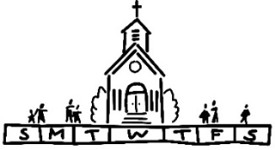
THIS WEEK
Today: In-person and Zoom Worship, 9:30 a.m.
Sunday School for Children, 9:30 a.m.
5th Sunday Cash Plate for Concrete Steps
Lorrine Brandes Visitation, 12:00 p.m.
Lorrine Brandes Memorial Service, 1:00 p.m.
Game Night, 6:00-8:00 p.m.
Monday: Al-Anon, 9:30-11:00 a.m.
ServSafe Class, 6:00 p.m.
Tuesday: Quilters, 8:30 a.m.
Bible Study, 12:30 p.m.
Wednesday: TOPS, 9:00 a.m.
Cemetery Meeting, 6:00 p.m.
Thursday: ServSafe Class & Exam, 6:00 p.m.
Next Sunday: In-person and Zoom Worship, 9:30 a.m.
Sunday School for Children, 9:30 a.m.
Communion & Noisy Offering
Distribute Catch-Up Letters & Giving Statements

MISSION OF THE MONTH
The July MOM is the Madison County Advocacy Center. A list of items needed for donations is enclosed in the Herald. Donations can be placed on a table in the Narthex.

SCRIP
The July and August scrip orders will be combined with orders submitted the first Sunday in August. Third Sunday schedule will be resumed in September and October. Orders will be submitted second Sunday in November and December to accommodate holiday delivery schedules. Confused? You are not alone!!! Order schedules will be repeated as time grows nearer.
If you are planning to order scrip cards to donate for Trivia Night raffle or attendance prizes, please order August 6th (refer to Trivia Night announcement for more details). Orders for personal use always appreciated. Master list of vendors and St John ”favorites“ order forms are on the table in the Narthex. Give order
-6-
form and check payable to St. John UCC to Betty Meszaros at any time. Cash is also accepted but only if giving order to Betty in person. You can still participate in the program if not attending in-person worship. Just drop off or mail your check to the church
with a note of cards you are ordering. Cost is face value of the card with no tax or service fee. Rebate is automatically sent to the church. Contact Melissa Lane 314-575-7627 or Betty Meszaros 618-451-1968 questions.

On August 19, 2023 we will be having our church barbecue fundraiser. It will take place from 11:00 a.m. to 5:00 p.m. or until we sell out of items. The menu includes the following:
1lb Pork Steak & 2 Sides - $12.00
Bratwurst & 2 Sides - $12.00
¼ lb Hot Dog & 1 Side - $6.00
Side options will include Relleke Corn, baked beans, and potato salad. Desserts will also be available for an additional cost. Tickets will be available for pre-sale soon.

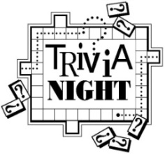
Trivia Night is back! For the first time since 2019, plans are in progress for a fun-filled Trivia Night on Saturday, August 26th. Invite family and friends. Since this is an alcohol-free event, older children are welcome IF they can be disconnected from cell phones. Cost is $120 per table if you have one or any number up to the maximum of eight players per table. First and second place prizes awarded to winning tables. Popcorn, lemonade, tea and water are included and you can bring your own food and beverages (no alcohol please).
August 6 - Scrip order submitted for “Great Gift Card Giveaway” also known as “Super Duper Gift Card basket” raffle. Rather than the traditional silent auction offered only to those attending the
-7-
event, this raffle will be open to all who purchase an entry slip. The value of “basket” will be determined by amount of gift cards
received. Donations appreciated from the congregation of cards purchased through the scrip program or elsewhere and in any denomination. If donating cards outside of scrip program, please give to Betty Meszaros or drop off at the church office by August 6th to allow time to assemble for entry sales.
August 13 - Entry slips for the “Great Gift Card Giveaway” will be sold in fellowship hall after worship service. Total value will be announced. Charge will be $1 each, six for $5 , twelve for $10 or twenty-five for $20. Drawing will be at the August 26 Trivia Night. Winner need not be present.
August 20 - “Great Gift Card Giveaway” chances sold during fellowship hour. This is also Rally Day so plan to stay for lunch and afternoon fellowship time.
August 23 - Deadline to register your table. Registration forms on back of inserts in bulletin. Pre-payment is appreciated but sometimes not logistically possible so payment accepted night of the event. Contact church office at 618-877-6060 if questions.
Proceeds from event will be used to purchase new computer equipment for church office and chairs for cemetery chapel.

ANNUAL FALL MUM SALE
It’s time to order your mums in our Annual Fall Mum Sale! Mums are 9 inches and $12.00 each with the color choices of bronze/orange, red, white, yellow, and pink/purple. Order forms are available on the table in the Narthex and will be included in the August Herald. Forms are due to the church office no later than Sunday, August 27th, with estimated pick-up being either September 16th or 23rd. Payment is due at the time your order is placed. If you have any questions, please call the church office at 618-877-6060.

3RD GRADE BIBLE PRESENTATIONS
Any of our children entering 3rd grade next August may receive a special Bible on Sunday, September 17, during 9:30 a.m. worship. Please call the church office at 618-877-6060 to give
-8-
name and address for letters to be sent inviting them to participate.

PLASTIC BOTTLE CAP COLLECTION
We are collecting plastic bottle caps to assist Eleanor Reynolds in her Girl Scout bench project. Bottle caps should be put in the tub in the Narthex.

If sorting & cleaning are in your plans, this will be the perfect time to hold aside items to donate to the all-church rummage sale. The event will be held September 28th & 29th this year and items can be brought to the stage in Fellowship Hall between September 5th and September 27th. No large electronics or heavy items please. General rule of thumb: If you would have to pay for it to be recycled, item cannot be accepted. This sale is sponsored by the Evening Guild with assistance appreciated from family and friends. All proceeds are given to church projects or local charitable organizations. Please mark the following important dates on your calendar. Volunteers are especially needed during Set Up and Pricing:

Tuesday, September 26th – 9:00 a.m. Set up
Wednesday, September 27th – 9:00 a.m.
Pricing
Thursday, September 28th – 8:30 a.m. to
3:00 p.m. Open for Shoppers
Friday, September 29th – 8:30 a.m. to 12:00
p.m. Open for Shoppers

OUR PRAYERS
Hospital, Nursing, Assisted, & Independent Living
Earl Buenger, Marcia Buenger, Ruth Buer, Myra Cook, Hilde Few, JoAnn King, Karen Luddeke, Merle Rose, Marjorie Schmidt, and Jerry Shonk.
At Home
Chloe Affolter, Isabella Boyer, Carol Braundmeier, Christopher Clark, Bonnie Fornaszewski, Mary Franz, Luitgard Fries, Melba
-9-
Grady, Lou Hasse, Chuck King, Mina McBrian, Cindy Meyer, Sandy Mueller, Cliff Robertson, June Stille, and Nancy Wilson.
Illinois South Conference
Columbia St. Paul UCC, Rev. Jonathan Bangera. New Baden, Rev. Stephen (Molly) Stark. Retired Pastor, Rev. Dr. Don and Nancy Wagner, Marissa, IL.

SCRIPTURE READINGS
Genesis 29:15-28
¹⁵ Then Laban said to Jacob, “Because you are my kinsman, should you therefore serve me for nothing? Tell me, what shall your wages be?” ¹⁶ Now Laban had two daughters; the name of the elder was Leah, and the name of the younger was Rachel. ¹⁷ Leah’s eyes were weak, but Rachel was graceful and beautiful. ¹⁸ Jacob loved Rachel, so he said, “I will serve you seven years for your younger daughter Rachel.” ¹⁹ Laban said, “It is better that I give her to you than that I should give her to any other man; stay with me.” ²⁰ So Jacob served seven years for Rachel, and they seemed to him but a few days because of his love for her. ²¹ Then Jacob said to Laban, “Give me my wife that I may go in to her, for my time is completed.” ²² So Laban gathered together all the people of the place and made a feast. ²³ But in the evening he took his daughter Leah and brought her to Jacob, and he went in to her. ²⁴ (Laban gave his maid Zilpah to his daughter Leah to be her maid.) ²⁵ When morning came, it was Leah! And Jacob said to Laban, “What is this you have done to me? Did I not serve with you for Rachel? Why then have you deceived me?” ²⁶ Laban said, “This is not done in our country—giving the younger before the firstborn. ²⁷ Complete the week of this one, and we will give you the other also in return for serving me another seven years.” ²⁸ Jacob did so and completed her week; then Laban gave him his daughter Rachel as a wife.
Matthew 13:31-33, 44-52
³¹ He put before them another parable: “The kingdom of heaven is like a mustard seed that someone took and sowed in his field; ³² it is the smallest of all the seeds, but when it has grown it is the greatest of shrubs and becomes a tree, so that the birds of the air come and make nests in its branches.” ³³ He told them another parable: “The kingdom of heaven is like yeast that a

-10-
woman took and mixed in with three measures of flour until all of it was leavened.”
⁴⁴ “The kingdom of heaven is like treasure hidden in a field, which a man found and reburied; then in his joy he goes and sells all that he has and buys that field.
⁴⁵ “Again, the kingdom of heaven is like a merchant in search of fine pearls; ⁴⁶ on finding one pearl of great value, he went and sold all that he had and bought it.
⁴⁷ “Again, the kingdom of heaven is like a net that was thrown into the sea and caught fish of every kind; ⁴⁸ when it was full, they drew it ashore, sat down, and put the good into baskets but threw out the bad. ⁴⁹ So it will be at the end of the age. The angels will come out and separate the evil from the righteous ⁵⁰ and throw them into the furnace of fire, where there will be weeping and gnashing of teeth.
⁵¹ “Have you understood all this?” They answered, “Yes.” ⁵² And he said to them, “Therefore every scribe who has become a disciple in the kingdom of heaven is like the master of a household who brings out of his treasure what is new and what is old.”

Try our QR code! This little square will take you directly to our secure MyVanco website where you can contribute to any of our various funds. Just follow three simple steps:

- Open your smart phone’s camera app
- Aim the camera at the black and white square below and a link will appear on your screen.
- Click the link and you’ll be directed to our donations website. From there, you can select a fund to which you’d like to make a contribution.

Thank you!

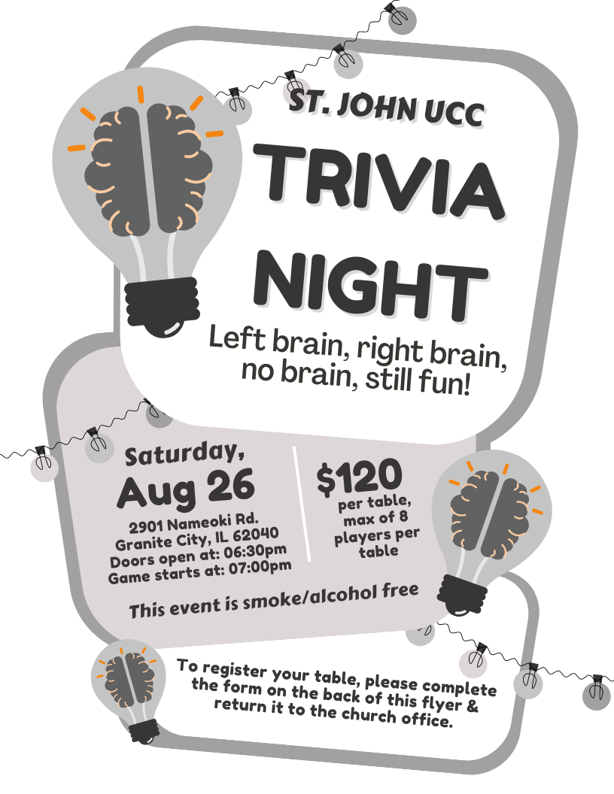

St. John UCC Trivia Night
Table Registration Form

This form is due in the church office by Wednesday, August 23rd.

You can also submit your registration by phone (call 618-877-6060) or by email (send information to stjohnuccevents@gmail.com)

CONTACT NAME ____________________________________

CONTACT PHONE NUMBER ___________________________

PAYMENT ENCLOSED (please circle one) YES NO

Doors will open at 6:30 p.m. and the game will start at 7:00 p.m. Cost is $120.00 per table, with a max of 8 players at each table. Cash Prizes will be awarded to the 1st & 2nd place tables. Prizes will also include:
- 1 Super-Duper Gift Card Basket Drawing (chances sold before August 26th and during the evening of the 26th before the drawing)
- 50/50 drawing
- 1 Attendance prize drawing per round

Popcorn, iced tea, lemonade, coffee and ice will be provided at no additional cost.

This event is smoke & alcohol free.

FOOD BOX PROJECT
On Saturday, September 9th, we will continue our church’s Food Box Give-Away Program to help fight hunger in the community. Food prices are high, as we all know, which means it will cost more to fill the boxes. To offset the costs, we are once again asking for donations of food from the congregation. Also, if anyone has any contacts for food donations, such as grocery stores, produce markets, food manufacturers, dairies, etc., please let us know. During the March distribution, we gave away 180 boxes. We are hoping to distribute at least 150 - 175 boxes.

For those who would like to donate food for this project, the following is a suggested list to follow. Dates of collection for specific items have been included. If anyone has items to donate that do not appear on the list or would like to donate them on a different Sunday than what is listed, feel free to do so. Please make sure items being donated are not expired. Both Name Brand items and store brands are acceptable items to donate. Watch for sales at Schnucks, Ruler (they send out coupons), Aldi, Walmart, Sam’s, etc. The congregation’s generosity and participation has been tremendous for this project as well as all the others that have been implemented.

Suggested donations and dates:
Sun, 6-11-23 | Canned soup (chicken noodle, vegetable, tomato, etc.) or vegetable canned goods*
Sun, 6-18-23 | Canned chili & stew*
Sun, 6-25-23 | Boxed cereal (Cheerios, Rice Krispies, Corn Flakes, avoid sugary cereals such as Froot Loops)
Sun, 7-2-23 | Peanut butter 16 oz jar (Ruler has the lowest price to date)
Sun, 7-9-23 | Jars of applesauce (The Kroger brand is inexpensive)
Sun, 7-16-23 | Canned Spaghetti Os (Campbells) or Spaghetti & Meat Balls or Lasagna (Chef Boyardee). It can be similar products under other manufacturers as well.
Sun, 7-23-23 | Canned tuna or 2lb bag of rice
Sun, 7-30-23 | 64 oz bottles of juice - apple cranberry, grape - (Dollar Tree has inexpensive options)
Sun, 8-6-23 | Mac & cheese dinners
Sun, 8-13-23 | Vegetable canned goods*
Sun, 8-20-23 | 5 lb bag of flour
Sun, 8-27-23 | Canned chili & stew*
*These items are listed twice due to the high volume needed
FOOD BOX PROJECT
On Saturday, September 9th, we will continue our church’s Food Box Give-Away Program to help fight hunger in the community. Food prices are high, as we all know, which means it will cost more to fill the boxes. To offset the costs, we are once again asking for donations of food from the congregation. Also, if anyone has any contacts for food donations, such as grocery stores, produce markets, food manufacturers, dairies, etc., please let us know. During the March distribution, we gave away 180 boxes. We are hoping to distribute at least 150 - 175 boxes.

For those who would like to donate food for this project, the following is a suggested list to follow. Dates of collection for specific items have been included. If anyone has items to donate that do not appear on the list or would like to donate them on a different Sunday than what is listed, feel free to do so. Please make sure items being donated are not expired. Both Name Brand items and store brands are acceptable items to donate. Watch for sales at Schnucks, Ruler (they send out coupons), Aldi, Walmart, Sam’s, etc. The congregation’s generosity and participation has been tremendous for this project as well as all the others that have been implemented.

Suggested donations and dates:
Sun, 6-11-23 | Canned soup (chicken noodle, vegetable, tomato, etc.) or vegetable canned goods*
Sun, 6-18-23 | Canned chili & stew*
Sun, 6-25-23 | Boxed cereal (Cheerios, Rice Krispies, Corn Flakes, avoid sugary cereals such as Froot Loops)
Sun, 7-2-23 | Peanut butter 16 oz jar (Ruler has the lowest price to date)
Sun, 7-9-23 | Jars of applesauce (The Kroger brand is inexpensive)
Sun, 7-16-23 | Canned Spaghetti Os (Campbells) or Spaghetti & Meat Balls or Lasagna (Chef Boyardee). It can be similar products under other manufacturers as well.
Sun, 7-23-23 | Canned tuna or 2lb bag of rice
Sun, 7-30-23 | 64 oz bottles of juice - apple cranberry, grape - (Dollar Tree has inexpensive options)
Sun, 8-6-23 | Mac & cheese dinners
Sun, 8-13-23 | Vegetable canned goods*
Sun, 8-20-23 | 5 lb bag of flour
Sun, 8-27-23 | Canned chili & stew*
*These items are listed twice due to the high volume needed
“Seek Ye First”
Words & Music: Karen Lafferty © 1972 Maranatha! Music (Admin. The Copyright Company). Reprinted by permission, CCLI License #1334401.
Seek ye first the kingdom of God
And its righteousness,
And all these things shall be added unto you;
Alleluia, alleluia!

Ask, and it shall be given unto you,
Seek and ye shall find,
Knock and the door shall be opened unto you;
Alleluia, alleluia!

“God of the Ages, History’s Maker”
Words: Margaret Clarkson © 1982 Hope Publishing Company. Reprinted by permission, CCLI License #1334401.
God of the ages, history’s Maker,
Planning our pathway, holding us fast,
Shaping in mercy all that concerns us:
Father, we praise you, -- Lord of the past.

God of this morning, gladly your children
Worship before you, trustingly bow:
Teach us to know you always among us,
Quietly sovereign -- Lord of our now.

God of tomorrow, strong overcomer,
Princes of darkness own your command:
What then can harm us? We are your people,
Now and forever kept by your hand.

Lord of past ages, Lord of this morning,
Lord of the future, help us, we pray:
Teach us to trust you, love and obey you,
Crown you each moment, Lord of today.

“All the Way My Savior Leads Me”
All the way my Savior leads me;
What have I to ask beside?
Can I doubt his tender mercy,
Who through life has been my guide?
Heavenly peace, divinest comfort,
Here by faith in him to dwell,
For I know, whate’er befall me,
Jesus doeth all things well;

All the way my Savior leads me,
Cheers each winding path I tread,
Gives me grace for every trial,
Feeds me with the living bread.
Though my weary steps may falter,
And my soul athirst may be,
Gushing from the rock before me,
Lo! A spring of joy I see.

All the way my Savior leads me;
O the fullness of his love!
Perfect rest to me is promised
In my Father’s house above;
When my spirit, clothed immortal,
Wings its flight to realms of day,
This my song through endless ages,
Jesus led me all the way.

