St. John United Church of Christ
“In Christ We Live, Celebrate, & Serve”

May 7, 2023 | 5th Sunday of Easter(A)
Rev. Karla Frost, Pastor | Chris McMillan, Guest Organist
9:30 Zoom & In-Person Worship | 9:30 Sunday School for Children
2901 Nameoki Road | Granite City, IL 62040
E-stjohnucc2901gc@yahoo.com | (618) 877-6060
Web-stjohnuccgranitecity.com
Large print bulletins are available from the Ushers.
Bold italic denotes congregation reads or sings.
*Denotes all who are able, please stand.

WE COME TO WORSHIP GOD

PRE-SERVICE MUSIC, WELCOME AND ANNOUNCEMENTS

BELLS CALLING TO WORSHIP

A STORY FOR ALL GOD’S CHILDREN 1 Peter 2:2-10
“…proclaim the mighty acts of [God] who called you out of darkness into his marvelous light.” (Vs. 9b)

PRELUDE AND CENTERING OUR HEARTS ON WORSHIP
O Lord Most Holy F. Abt

CALL TO WORSHIP AND CONFESSION
Adapted from 1 Peter 2 and Acts 7
Come to worship the Lord and know that he is good.
We come to be built into a spiritual house,
To offer spiritual sacrifices acceptable to God.
We come as God’s own people.
Seeking mercy when we stumble.
Let us pray together:
Lord, forgive us when we try to ignore our own sins, but see the sins of others. Forgive us when we stand by and condone what you condemn. Grant us trust in your righteous ways and strengthen us to hold fast to what is good, even in the face of evil. Amen.
As Stephen prayed, “Lord, do not hold this sin against them,” we pray for ourselves and others, and receive mercy.
Thanks be to God who never fails us.

-2-
*HYMN “A Mighty Fortress Is Our God” #507

*RESPONSIVE PSALTER READING Psalm 31:1-5, 15-16
In you, O Lord, I seek refuge;
Do not let me ever be put to shame;
In your righteousness deliver me.
Incline your ear to me;
Rescue me speedily.
Be a rock of refuge for me,
A strong fortress to save me.
You are indeed my rock and my fortress;
For your name’s sake lead me and guide me,
Take me out of the net that is hidden for me,
For you are my refuge.
Into your hand I commit my spirit;
You have redeemed me, O Lord, faithful God.
My times are in your hand;
Deliver me from the hand of my enemies and persecutors.
Let your face shine upon your servant;
Save me in your steadfast love.

WE HEAR GOD’S WORD

NEW TESTAMENT LESSON Acts 7:55-60 pg. 118

ANTHEM Amazing Grace Chancel Choir

GOSPEL LESSON John 14:1-14 pg. 102

REFLECTION

WE RESPOND TO GOD’S WORD

*HYMN “Be Still, My Soul” #451

PASTORAL PRAYER

RESPONSE “The Lord’s Prayer” (One Amen) #740

THE SACRAMENT OF HOLY COMMUNION

STEWARDSHIP INVITATION

OFFERTORY Olivet Blake
-3-
*SUNG RESPONSE “We Give Thee but Thine Own”
Vss. 1, 2, & 4 #688
We give thee but thine own, whate’er the gift may be;
all that we have is thine alone, a trust, O Lord, from thee.

May we thy bounties thus as stewards true receive,
and gladly, as thou blessest us, to thee our first-fruits give.

The captive to relieve, to God the lost to bring,
to teach the way of life and peace—it is a Christ-like thing.

*UNISON PRAYER OF DEDICATION
Holy Lord, we believe that what we do in your name does make a difference in the world. We want to share your truth and life in the best ways possible. Bless these offerings that they may bring hope and peace in places of distress and in places of great opportunity through your steadfast love. Amen.

INVITATION From You Satisfy the Hungry Heart, Hymn #705
As when the shepherd calls his sheep,
they know and heed his voice,
So when you call your family, Lord,
we follow and rejoice.
The mystery of your presence, Lord,
no mortal tongue can tell:
Whom all the world cannot contain,
comes in our hearts to dwell.
You satisfy the hungry heart with gift of finest wheat,
Come give to us, O saving Lord, the bread of life to eat.

COMMUNION PRAYER

BREAKING, POURING AND PARTAKING

*UNISON PRAYER OF THANKSGIVING
We thank you, Redeeming God, for the glorious message that you bring new hope out of despair, victory out of defeat, and new life out of death. At this table we have received the risen presence of Christ into our hearts and lives. And now we go as his disciples to share the good news with joy: He is alive, forevermore. Amen.
-4-
*HYMN & NOISY OFFERING FOR CONCRETE STEPS
“When Morning Gilds the Skies” #111

*BENEDICTION

*POSTLUDE Praise, My Soul, the King of Heaven arr. Smith

You are a royal priesthood, God's own people. Welcome to worship, that we may proclaim the mighty acts of God, who called us into his marvelous light.

If you would like to place flowers on the altar, and pick them up after church or on Monday, please call Karen Orr at (618) 558-4192. If you would like to sponsor the bulletins, please call the church office at (618) 877-6060. The next available dates to sponsor the bulletin are July 16th & 30th.

Thank you to Rev. Charles Preston for serving as liturgist, to Dorothy Kinney for greeting, and to Chris McMillan for serving as guest organist.

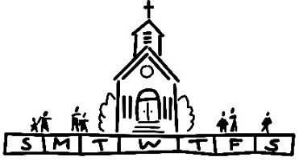
THIS WEEK
Today: In-person and Zoom Worship, 9:30 a.m.
Sunday School for Children, 9:30 a.m.
Communion & Noisy Offering
Monday: Al-Anon, 9:30 a.m.
Brotherhood, 6:30 p.m.
Tuesday: Quilters, 8:30 a.m.
Hilltoppers, 12:30 p.m.
Bible Study, 12:30 p.m.
Christian Ed/Worship/Fellowship Meeting, 6:00
p.m.
Wednesday: TOPS, 9:00 a.m.
Bell Choir, 5:30 p.m.
Thursday: Council Meeting, 6:00 p.m.
Friday: Flower Basket Pickup & Sale
-5-
Saturday: Flower Basket Pickup & Sale
Next Sunday: Mother’s Day
In-person and Zoom Worship, 9:30 a.m.
Sunday School for Children, 9:30 a.m.
Begin Blankets & Tools Offering

MISSION OF THE MONTH
Our May Mission of the Month is dedicated to the Church World Service Blankets and Tools offering. For those who are experiencing difficult times, these blankets and other items serve as a warm and comforting reminder that they are loved. Envelopes were included in the May edition of the Herald. Additional envelopes can be found in the pews.

SECOND QUARTER NOISY OFFERING
The second quarter noisy offering is designated for replacement of the outdoor concrete steps.

Thank you to everyone who helped make yesterday’s barbecue a great success! Events like these would not be possible without the hard work of our volunteers.

HANGING BASKET PICKUP
If you placed a preorder for the hanging baskets, the pickup will be Friday, May 12th from 12:00 to 4:00 and Saturday, May 13th from 9:00 to 3:00. You will be contacted when the baskets have been delivered to the church and are available for pickup. If you did not order hanging baskets, no worries! There will be extra baskets available for purchase at $18.50 each. So if you’re trying to figure out a Mother’s Day gift for Mom, this would be a great option!
-6-
SCRIP
Is June still the most popular month for weddings? Consider gift cards to a store on the registry. Do you know a high school graduate heading off to college? A gift card to Target might be useful to decorate the new dorm room. Master list of vendors and St. John “favorites” order forms are on the table in the narthex.
Give order form and check payable to St John UCC to Betty Meszaros at any time. Cash is also happily accepted but only if giving order to Betty in person. Orders will be held until the third Sunday of each month and submitted then. Exception if total order does not cover shipping cost which is currently $10.50 per shipment. You can still participate in the program if not attending in-person worship. Just drop off or mail your check to the church with a note of cards you are ordering. Cost is face value of the card with no tax or service fee. Rebate is automatically sent to church. Contact Melissa Lane at 314-575-7627 or Betty Meszaros at 618-451-1968 if any questions.

NEW MEMBERS
Following our tradition, new members will be received on Pentecost Sunday, May 28, 2023. Please speak to Pastor Karla to set up a membership preparation time if you would like to covenant with St. John UCC then.

OUR PRAYERS
Nursing, Assisted, & Independent Living
Cedarhurst of Granite City, Memory Care, 3432 Village Lane, Granite City, IL 62040
JoAnn King, #113,
Eden Village, 200 S. Station Rd., Glen Carbon, IL 62034
Earl & Marcia Buenger, Apt 9219
The Fountains of West County, 15822 Clayton Rd, Ellisville, MO 63011
Ruth Buer

-7-
Granite Nursing & Rehab, 3500 Century Dr, Granite City, IL 62040
Karen Luddeke
Jerry Shonk
Stillwater Senior Living, 1111 University Dr., Edwardsville, IL 62025
Marjorie Schmidt, #101
Villas of Holly Brook, 121 S. Bluff Rd, Collinsville, IL 62234
Hilde Few, #208
At Home
Chloe Affolter, 577 Newhart Dr., G.C., IL 62040
Isabella Boyer, 4722 S. Hazel, Edwardsville, IL 62025
Carol Braundmeier, 2228 Nevada, G.C., IL 62040
Christopher Clark, 2223 Lincoln Ave., G.C., IL 62040
Myra Cook, 4034 Stearns Ave., G.C., IL 62040
Bonnie Fornaszewski, 200 Carlson Ave., Apt. 17D, Washington, IL 61571
Mary Franz, 3117 Willow Ave., G.C., IL 62040
Luitgard Fries, 4117 Old Alton Rd., G.C., IL 62040
Lou Hasse, 2689 Westmoreland Dr. Unit 2, G.C., IL 62040
Norman Hente, 3708 Joyce St., G.C., IL 62040
Chuck King, 3258 Kilarney Dr., G.C., IL 62040
Cindy Meyer, 2206 Lynch Ave., G.C. IL 62040
Sandy Mueller, 308 Warson Ln., G.C., IL 62040
Cliff Robertson, 2336 O’Hare Ave., G.C., IL 62040
Merle Rose, 2447 Waterman Ave., G.C., IL 62040
June Stille, 49 Riviera, G.C., IL 62040
Nancy Wilson, 4062 Sarah St. Apt 81, G.C., IL 62040
Illinois South Conference
Summerfield St. John UCC, Rev. Philip (Kate) Barbier. Tower Hill St. Paul UCC, Pastor Neil Kaiser. Retired Pastor, Revs. Pamela Smith and Earl Menchhofer, Conyers, GA.

SCRIPTURE READINGS
Acts 7:55-60
⁵⁵ But filled with the Holy Spirit, he gazed into heaven and saw the glory of God and Jesus standing at the right hand of God. ⁵⁶ “Look,” he said, “I see the heavens opened and the Son of Man standing at the right hand of God!” ⁵⁷ But they covered their ears, and with a loud shout all rushed together against
-8-
him. ⁵⁸ Then they dragged him out of the city and began to stone him, and the witnesses laid their coats at the feet of a young man named Saul. ⁵⁹ While they were stoning Stephen, he prayed, “Lord Jesus, receive my spirit.” ⁶⁰ Then he knelt down and cried out in a loud voice, “Lord, do not hold this sin against them.” When he had said this, he died.

John 14:1-14
“Do not let your hearts be troubled. Believe in God; believe also in me. ² In my Father’s house there are many dwelling places. If it were not so, would I have told you that I go to prepare a place for you? ³ And if I go and prepare a place for you, I will come again and will take you to myself, so that where I am, there you may be also. ⁴ And you know the way to the place where I am going.” ⁵ Thomas said to him, “Lord, we do not know where you are going. How can we know the way?” ⁶ Jesus said to him, “I am the way and the truth and the life. No one comes to the Father except through me. ⁷ If you know me, you will know my Father also. From now on you do know him and have seen him.” ⁸ Philip said to him, “Lord, show us the Father, and we will be satisfied.” ⁹ Jesus said to him, “Have I been with you all this time, Philip, and you still do not know me? Whoever has seen me has seen the Father. How can you say, ‘Show us the Father’? ¹⁰ Do you not believe that I am in the Father and the Father is in me? The words that I say to you I do not speak on my own, but the Father who dwells in me does his works. ¹¹ Believe me that I am in the Father and the Father is in me, but if you do not, then believe because of the works themselves. ¹² Very truly, I tell you, the one who believes in me will also do the works that I do and, in fact, will do greater works than these, because I am going to the Father. ¹³ I will do whatever you ask in my name, so that the Father may be glorified in the Son. ¹⁴ If in my name you ask me for anything, I will do it.

-9-
Try our QR code! This little square will take you directly to our secure MyVanco website where you can contribute to any of our various funds. Just follow three simple steps:

- Open your smart phone’s camera app
- Aim the camera at the black and white square below and a link will appear on your screen.
- Click the link and you’ll be directed to our donations website. From there, you can select a fund to which you’d like to make a contribution.

Thank you!

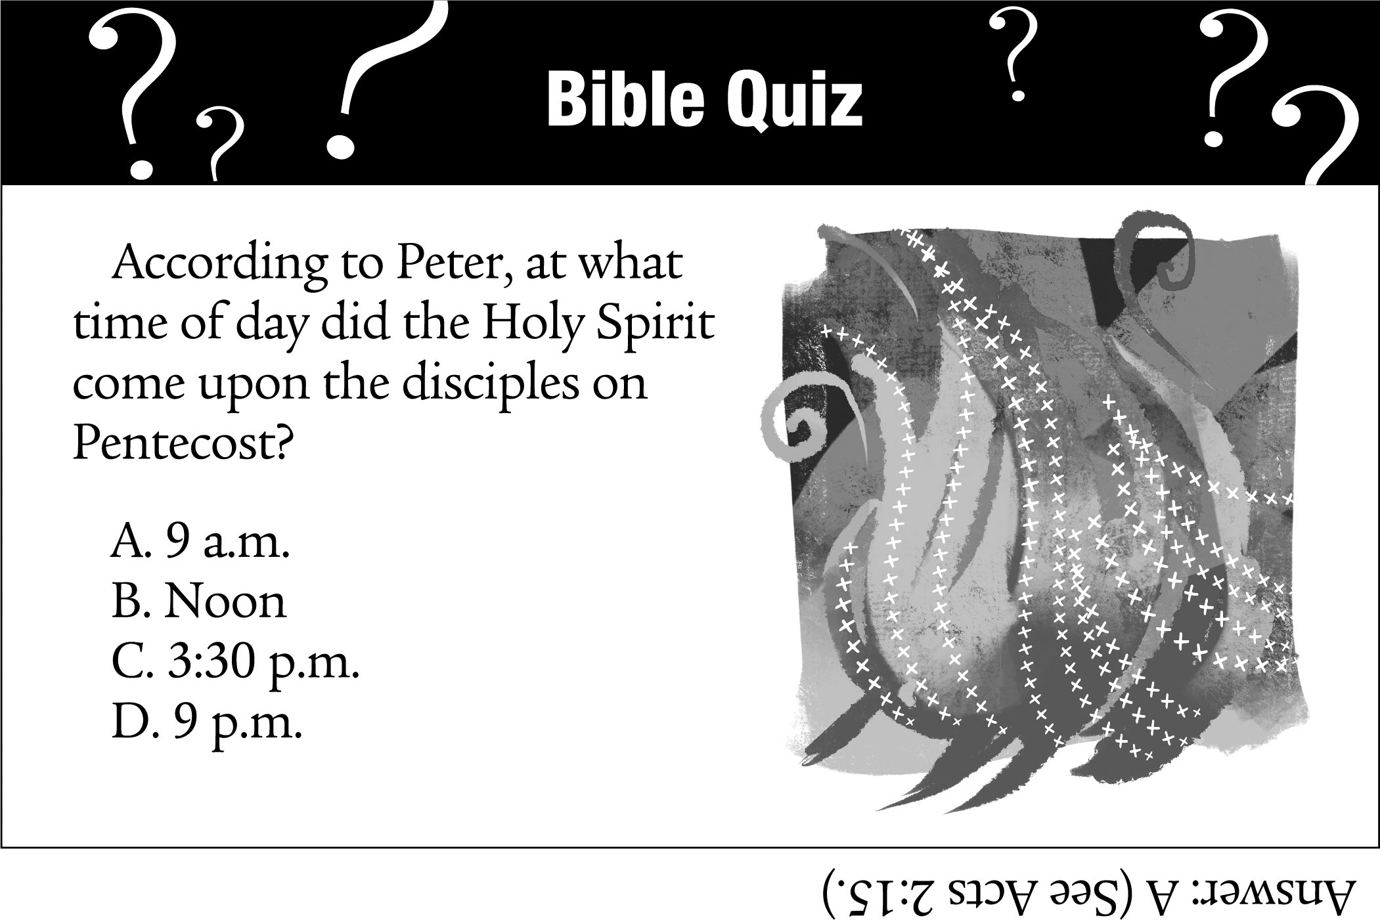

-10-
CALL FOR INFORMATION
Bell Choir – Talk to Kathy Morris, 618-210-6095
Cemetery – Talk to Kathy Montgomery, 618-876-5811
Chancel Choir – Talk to John Nitchman, President, 618-288-5297
Council – Talk to Kiki Cochran, President, 618-797-2511 or Donna Brandes, Vice President, 618-802-1072
Evening Guild – Talk to Christie Roth, 618-931-6194
Financial Reports – Talk to Mike Seibold, Treasurer, 618-792-4301
Angela Potter, 618-877-6060 church office
Heavenly Stars – Talk to Betty Meszaros, 618-451-1968
Karen Gaines, 618-288-0845
Herald – Talk to Angela Potter 618-877-6060 church office
Hilltoppers – Talk to Dee Roethemeyer, 618-876-6860
Historian – Talk to Sandy Dawson, 618-931-3467
Men’s Brotherhood – Talk to Chuck Hasse, 618-876-0936,
Dave Douglas, 618-452-3336
Quilters – Talk to Sandy Dawson 618-931-3467
Doris Peterson 618-877-1606
Sausage Dinner – Talk to Donna Brandes, 618-802-1072
Nancy Jacobs, 618-931-0673
Scrip Orders – Talk to Melissa Lane, 314-575-7627 or Betty Meszaros 618-451-1968
Sunday School – Talk to Donna Brandes, 618-802-1072
Youth Fellowship – Talk to Sharon O’Toole, 314-420-1548

