**St. John United Church of Christ**

***“In Christ We Live, Celebrate, & Serve”***

|  |  |
| --- | --- |
| February 12, 2023 | 6th Sunday after Epiphany (A) |
| Rev. Karla Frost, Pastor |  |
| 9:30 Zoom & In-Person Worship | 9:30 Sunday School for Children |
| 2901 Nameoki Road | Granite City, IL 62040 |
| E-stjohnucc2901gc@yahoo.com | (618) 877-6060 |

Web-stjohnuccgranitecity.com

**Currently face masks are RECOMMENDED.**

Large print bulletins are available from the Ushers.

***Bold italic denotes congregation reads or sings.***

*Denotes all who are able, please stand.

**WE COME TO WORSHIP GOD**

PRE-SERVICE MUSIC, WELCOME AND ANNOUNCEMENTS

*You’re the Inspiration* Chicago

BELLS CALLING TO WORSHIP

A STORY FOR ALL GOD’S CHILDREN Deuteronomy 30:15-20

“See, I have set before you today life and prosperity, death and adversity. If you obey the commandments of the Lord your God,…by loving the Lord your God, walking in his ways, and observing his commandments, decrees, and ordinances, then you shall live and become numerous,…

PRELUDE AND CENTERING OUR HEARTS ON WORSHIP

*You’ll Always Be the One I Love* Sinatra

CALL TO WORSHIP AND PRAYER1

Come, walk in the way that leads to life.

***It is better to be reconciled with another***

***than to be proven right.***

Come, choose to live a genuine life.

***Life is too short for petty resentments.***

Come, walk in the way Christ invites us to travel.

***We give thanks for Christ’s way,***

***and for the freedom to follow!***

Let us pray together:

***Open our eyes, Holy Spirit, to your love in our midst. We give you thanks for the power of our minds to choose right over wrong. Guide us now, that this power may not***

-2-

***overwhelm, but inspire us. Help us choose compassion for ourselves and others. Teach us to set aside old resentments and grudges. Lift us, with all earth’s children and all your creation, to aspire to the abundant life Christ brings. Amen.***

***Amen.***

*HYMN ***“The Church’s One Foundation”*** #544

*PRAYER LITANY OF COMMITMENT1 AND PSALM 119:5

The choices God gives us have the power to set us free.

***God, help us to choose life this day.***

“O that my ways may be steadfast…”

***God, help us choose reconciliation over our pride,***

“O that my ways may be steadfast…”

***God, help us choose self-compassion over self-condemnation,***

“O that my ways may be steadfast…”

***God, help us choose committed love over reckless desire,***

“O that my ways may be steadfast…”

***God, help us choose hope-filled friendships over competition.***

Every day, and in each moment, teach us, Eternal Parent,

***To love ourselves and this world in the way you always love us. Amen.***

**WE HEAR GOD’S WORD**

EPISTLE LESSON I Corinthians 3:1-4, 13:1-13 pgs. 156 & 164

RECORDED ANTHEM *Love Will Never Fail* The Porter’s Gate

GOSPEL LESSON Matthew 5:21-24, 38-48 pg. 4

SERMON

**WE RESPOND TO GOD’S WORD**

*HYMN ***“Blest Be the Tie that Binds”*** #393

PASTORAL PRAYER & UNISON LORD’S PRAYER

-3-

***Our Father, who art in heaven, hallowed be thy name. Thy kingdom come; thy will be done on earth as it is in***

***heaven. Give us this day our daily bread, and forgive us our debts as we forgive our debtors; and lead us not into temptation, but deliver us from evil; for thine is the kingdom and the power, and the glory forever. Amen.***

STEWARDSHIP INVITATION WITH PERSONAL STATEMENTS OF FAITH

OFFERTORY  *In My Life* Beatles

*RESPONSE ***“Praise God from Whom All Blessings Flow”***

***Praise God from whom all blessings flow;*** #34

***praise him, all creatures here below;***

***praise him above, ye heavenly host:***

***praise Father, Son and Holy Ghost. Amen.***

*UNISON PRAYER OF DEDICATION1

***These offerings belong to you, O Lord, for you are the source of every blessing and joy. Employ these gifts to build your realm. Send them into the world to heal the sick, feed the hungry, and reconcile us to one another. By our prayers, our presence, our gifts, and our service, make your church a true instrument of peace. Amen.***

*HYMN  ***“They’ll Know We Are Christians”***  #595

*BENEDICTION “Souper Bowl of Caring”

*RECORDED POSTLUDE *Heart and Soul* Carmichael

1From The Abingdon Worship Annual 2023. Copyright © 2022 by Abingdon Press. Used by permission.”

Paul tells us, “We are co-workers in God's service” (1 Corinthians 3:9, NIV). So we gather to be fed for a new week of ministry. Welcome!

If you would like to place **flowers on the altar**, and pick them up after church or on Monday, please call **Veronica Douglas** at (618) 806-4899. If you would like to sponsor the **bulletins**, please call the **church office** at (618) 877-6060. There next available

-4-

date to sponsor the bulletin is February 26th. There are also two available dates in May to sponsor bulletins: May 7th, and May 21st.

Thank you to **Kiki Cochran** for serving as liturgist, to **Conyr Fischer** for serving as acolyte, and to **Dan Comer** for serving as music technician today.

**THIS WEEK**

Today:In-person and Zoom Worship, 9:30 a.m.

Sunday School for Children, 9:30 a.m.

Confirmation, 11:00 a.m.-12:00 p.m.

Souper Bowl of Caring Collection

Monday: Al-Anon, 9:30-11:00 a.m.

Brotherhood Valentines Party, 6:30 p.m.

Tuesday: Quilters, 8:30 a.m.

Bible Study, 12:30 p.m.

Hilltoppers, 12:30 p.m.

Wednesday: TOPS, 9:00 a.m.

Bell Choir, 5:30 p.m.

Chancel Choir, 6:30 p.m.

Thursday: Granite City Community Band Rehearsal, 6:15-

9:45 p.m.

Saturday: **Bowls of Goodness, 4:00-7:00 p.m.**

Next Sunday: In-person and Zoom Worship, 9:30 a.m.

Sunday School for Children, 9:30 a.m.

Confirmation, 11:00 a.m.-12:00 p.m.

Fellowship Hour by Glockenspiel

**MISSION OF THE MONTH**

Our February Mission of the Month is dedicated to our Food Box Distribution Project. The next Food Box Distribution will be on Saturday, March 4, 2023 and benefits members of our community who are in need.

**FIRST QUARTER NOISY OFFERING**

Our first quarter Noisy Offering is designated for the Kielce Polish church helping Ukrainians.

-5-

**BROTHERHOOD**

The men’s Brotherhood Valentine’s Dinner is tomorrow, February 13, 2023 at 6:30 p.m. for those who made reservations. Next month, the Brotherhood will host a St. Patrick’s Day Dinner on March 13, 2023 at 6:30 p.m. Guest speaker, Barb Kay, will be giving a presentation on The Unsinkable Molly Brown. Reservations are also required for this event and should be made no later than Wednesday, March 8, 2023. You can call the church office (618-877-6060) or send an email to stjohnucc2901gc@yahoo.com to make your reservations.

**SCRIP**

The Scrip program is being resumed in February with plans to submit orders on February 19th with delivery the following Sunday. Master list of vendors and St. John “favorites” order forms will be on the table in the narthex. Give order form and check payable to St John UCC to Betty Meszaros at any time. Orders will be held until the third Sunday of each month and submitted then. Exception if total order does not cover shipping cost which is currently $10.50 per order. You can still participate in the program if not attending in-person worship. Just drop off or mail your check to the church with a note of cards you are ordering. Cost is face value of the card. Rebate is automatically sent to church. Cards are great as gifts but also easy to use personally. Contact Melissa Lane at 314-575-7627 or Betty Meszaros at 618-451-1968 if any questions.

**SOUPER BOWL OF CARING**

Today, February 12, we are participating in the national Souper Bowl of Caring collection, referencing the football Super Bowl extravaganza as a theme.  This is a non-denominational inter-faith project that 100% benefits local soup kitchens and hunger programs everywhere.  All our donations will be given directly to the Good Samaritan House, since Community Care is no longer offering prepared meals to the community.  The amount of money collected is reported to the national Souper Bowl of Caring office

-6-

so that a grand total for the day may be announced and celebrated. Youth with soup kettles will be at the doors today. Please be sure to carefully mark your donations for this collection so the offering counters know where to place them if giving by check. **OR**, another great option is to use the Donate button and Souper Bowl of Caring tab on our church website to make a secure electronic donation. Simply go to stjohnuccgranitecity.com for this option.

**BOWLS OF GOODNESS**

We have a full sign-up sheet for this event, which will feature some great local “celebrity chefs” as well as members from our own church community. They’ll offer their best soup or chili recipes and it’s up to YOU to determine which one is the best! Tickets are available for purchase in the church office. It’s $10.00 for unlimited soup and chili tasting, crackers, and 2 ballots to vote for your favorite entries! Drinks and desserts will be available for an additional cost. So mark your calendars forSaturday, February 18th from 4:00 to 7:00 p.m. for this event! We also need yummy desserts to sell at this event, so consider donating a pie, cake, brownies, or cookies, but please, no cheesecake, cream pumpkin, or dairy.

If you have any questions, please call the event chairperson, Kiki Cochran, at 618-503-3608 or the church office at 618-877-6060.



**ASH WEDNESDAY – EASTER SUNDAY**

This year Ash Wednesday is on February 22, and we will host a combined service with First United Presbyterian Church at 7:00 p.m. in our Sanctuary, and also on Zoom. The Imposition of Ashes for those present in-person, and the Sacrament of Holy

-7-

Communion, will be celebrated. Please plan to attend and begin the Lenten season with spiritual guidance.

And please mark your March/April calendars for these services and activities.

**March 12**, Daylight Savings Time, Girl Scout Sunday

**March 19**, One Great Hour of Sharing Offering

**March 26**, Confirmands’ Presentation Sunday

**April 2**, Palm/Passion Sunday, Communion, Rite of Confirmation, Fellowship Hour

**April 6**, Maundy Thursday, Confirmands’ & Family, Baptism Sponsors, Prayer Partners commune at the Table

**April 9**, Easter Sunday, Communion, Fellowship Hour

**OUR PRAYERS**

**Nursing, Assisted, & Independent Living**

Earl Buenger, Marcia Buenger, Ruth Buer, Hilde Few, JoAnn King, Mary Lee Krohne, Karen Luddeke, Leonard Schaefer, and Jerry Shonk.

**At Home**

Karen Anders, Chloe Affolter, Isabella Boyer, Carol Braundmeier, Christopher Clark, Myra Cook, Bonnie Fornaszewski, Mary Franz, Luitgard Fries, Melba Grady, Lou Hasse, Norman Hente, Chuck King, Cindy Meyer, Sandy Mueller, Cliff Robertson, Merle Rose, Marge Schmidt, June Stille, and Nancy Wilson.

**Illinois South Conference**

Marine UCC, Rev. Phil (Sandee) Kershner. Marion Zion UCC, Rev. John (Sara) Holst. Retired Pastor, Rev. Louis Fluck, Marion, IL. Rev. Shana Johnson, Conference Minister.



Please pray for the victims of the devastating earthquake in Turkey and Syria.

**SCRIPTURE READINGS**

**I Corinthians 3:1-4, 13:1-13**

And so, brothers and sisters, I could not speak to you as spiritual people but rather as fleshly, as infants in Christ. **2**I fed you with

-8-

milk, not solid food, for you were not ready for solid food. Even now you are still not ready, **3**for you are still fleshly. For as long as there is jealousy and quarreling among you, are you not fleshly and behaving according to human inclinations? **4**For when

one says, “I belong to Paul,” and another, “I belong to Apollos,” are you not all too human? .....

If I speak in the tongues of humans and of angels but do not have love, I am a noisy gong or a clanging cymbal. **2**And if I have prophetic powers and understand all mysteries and all knowledge

and if I have all faith so as to remove mountains but do not have love, I am nothing. **3**If I give away all my possessions and if I hand over my body so that I may boast but do not have love, I gain nothing. **4**Love is patient; love is kind; love is not envious or boastful or arrogant **5**or rude. It does not insist on its own way; it is not irritable; it keeps no record of wrongs; **6**it does not rejoice in wrongdoing but rejoices in the truth. **7**It bears all things, believes all things, hopes all things, endures all things. **8**Love never ends. But as for prophecies, they will come to an end; as for tongues, they will cease; as for knowledge, it will come to an end. **9**For we know only in part, and we prophesy only in part, **10**but when the complete comes, the partial will come to an end. **11**When I was a child, I spoke like a child, I thought like a child, I reasoned like a child. When I became an adult, I put an end to childish ways.

**12**For now we see only a reflection, as in a mirror, but then we will see face to face. Now I know only in part; then I will know fully, even as I have been fully known. **13**And now faith, hope, and love remain, these three, and the greatest of these is love.

**Matthew 5:21-24, 38-48**

**21**“You have heard that it was said to those of ancient times, ‘You shall not murder,’ and ‘whoever murders shall be liable to judgment.’ **22**But I say to you that if you are angry with a brother or sister, you will be liable to judgment, and if you insult a brother or sister, you will be liable to the council, and if you say, ‘You fool,’ you will be liable to the hell of fire. **23**So when you are offering your gift at the altar, if you remember that your brother or sister has something against you, **24**leave your gift there before the altar and go; first be reconciled to your brother or sister, and then come and offer your gift. .....

**38**“You have heard that it was said, ‘An eye for an eye and a tooth for a tooth.’ **39**But I say to you: Do not resist an evildoer. But

-9-

if anyone strikes you on the right cheek, turn the other also, **40**and if anyone wants to sue you and take your shirt, give your coat as well, **41**and if anyone forces you to go one mile, go also the second mile. **42**Give to the one who asks of you, and do

not refuse anyone who wants to borrow from you. **43**“You have heard that it was said, ‘You shall love your neighbor and hate

your enemy.’ **44**But I say to you: Love your enemies and pray for those who persecute you, **45**so that you may be children of your

Father in heaven, for he makes his sun rise on the evil and on the good and sends rain on the righteous and on the unrighteous.

**46**For if you love those who love you, what reward do you have? Do not even the tax collectors do the same? **47**And if you greet only your brothers and sisters, what more are you doing than others? Do not even the gentiles do the same? **48**Be perfect, therefore, as your heavenly Father is perfect.

**Try our QR code! This little square will take you directly to our secure MyVanco website where you can contribute to any of our various funds. Just follow three simple steps:**

1. **Qr code

   Description automatically generatedOpen your smart phone’s camera app**
2. **Aim the camera at the black and white square below and a link will appear on your screen.**
3. **Click the link and you’ll be directed to our donations website. From there, you can select a fund to which you’d like to make a contribution.**

**Thank you!**

-10-



|  |  |
| --- | --- |
| **WHERE**  St. John UCC  2901 Nameoki Rd.  Granite City, IL 62040 | **WHEN**  Saturday,  February 18th, 2023  4:00-7:00 p.m. |

Tickets are $10 for everyone 13+, $6 for ages 5-12 and free for children 4 and under. That buys you UNLIMITED soup and chili tasting, crackers, and 2 ballots to vote for your favorite entries!

Drinks and desserts will be available for an additional cost.

Local chefs and some of our own church chefs will be providing their specialty soups and chili!

Plan to make this an evening of fun! A 50/50 drawing and soup recipes will make this a great time for all!

Questions? Give us a call at 618-877-6060 or email us at [stjohnucc2901gc@yahoo.com](mailto:stjohnucc2901gc@yahoo.com)

Scan this QR code to check out our full submission list!

[](http://www.newsletternewsletter.com/searchart/ImageDetail.asp?image_id=95098046)

Please order a lily for me. Plants will cost **$12.00** each. Fill in the lines below exactly as you wish it to appear in the bulletin; (i.e., Mr., or Mrs., or

Miss, etc.) **DEADLINE** to order a lily is March 26, 2023.

(Please attach payments to this form and place either in the offering plate or bring it to the church office.) PLEASE PRINT CLEARLY !!!!

IN LOVING MEMORY OF________________________________________________________

__________________________________________________________

OR

IN HONOR OF___________________________________________________________

_____________________________________________________________

OR

IN GRATITUDE FOR_________________________________________________________

____________________________________________________________

BY

NAME:______________________________________________________

ADDRESS:___________________________________________________

TELEPHONE NUMBER:_______________________________________

# OF LILIES ORDERED __________

TOTAL ENCLOSED

(Make checks payable to: St. John United Church of Christ)

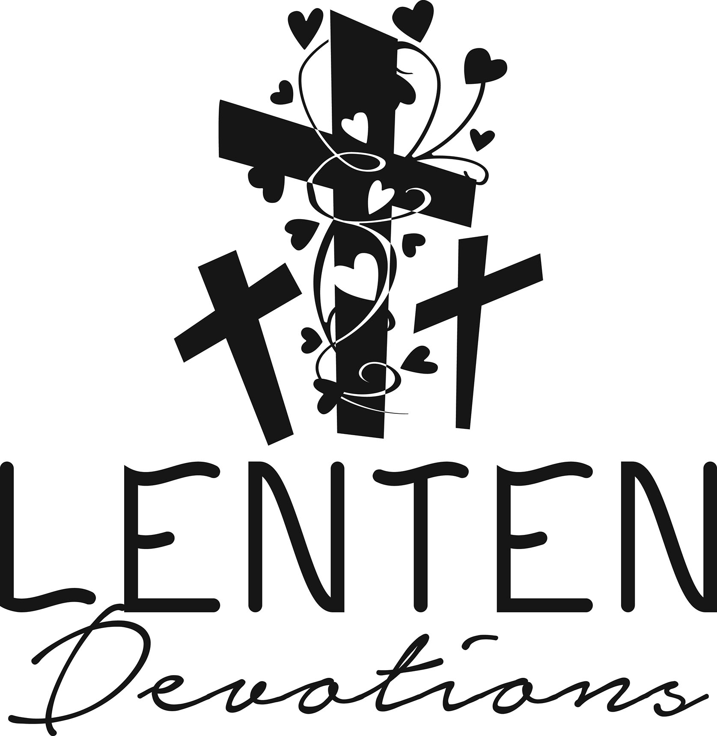

Lenten Spiritual Practice

Personal Statement of Faith

Meditate and Pray

Write One Section Each Week

February 22-February 28: We (I) believe God

March 1-March 7: We (I) believe Jesus Christ

March 8-March14: We (I) believe the Holy Spirit

March 15-March 21: We (I) believe the Sacrament of Baptism

March 22-March 28: We (I) believe the Sacrament of Holy Communion

March 29-April 4: We (I) believe the Universal Christian Church

April 5-April 9: We (I) believe that as children of God we

Sunday, April 16: Dedicate Personal Statements of Faith

2022-2023 Confirmation Class/Prayer Partners’

Statement of Belief Project

We believe God:

We believe Jesus Christ:

We believe the Holy Spirit:

We believe the Sacrament of Baptism:

We believe the Sacrament of Holy Communion:

We believe the Universal Christian Church:

We believe that as children of God we:

Blessing and honor, glory and power be unto God

the Father, Son, and Holy Spirit,

one God, now and forever. Amen.

***“The Church’s One Foundation”***

***The church’s one foundation***

***Is Jesus Christ her Lord;***

***She is his new creation,***

***By water and the word:***

***From heaven he came and sought her***

***To be his holy bride;***

***With his own blood he bought her,***

***And for her life he died.***

***Elect from every nation,***

***Yet one o’er all the earth,***

***Her charter of salvation:***

***One Lord, one faith, one birth;***

***One holy name she blesses,***

***Partakes one holy food,***

***And to one hope she presses***

***With every grace endued.***

***Though with a scornful wonder***

***We see her sore oppressed,***

***By schisms rent asunder,***

***By heresies distressed:***

***Yet saints their watch are keeping,***

***Their cry goes up, “How long?”***

***And soon the night of weeping***

***Shall be the morn of song.***

***‘Mid toil and tribulation,***

***And tumult of her war,***

***She waits the consummation***

***Of peace forevermore,***

***Till with the vision glorious***

***Her longing eyes are blest,***

***And the great Church victorious***

***Shall be the Church at rest.***

***Yet she on earth hath union***

***With God, the Three in One,***

***And mystic sweet communion***

***With those whose rest is won:***

***O happy ones and holy!***

***Lord, give us grace that we,***

***Like them, the meek and lowly,***

***On high may dwell with thee.***

***“Blest Be the Tie That Binds”***

***Blest be the tie that binds***

***Our hearts in Christian love;***

***The fellowship of kindred minds***

***Is like to that above.***

***Before our Father’s throne***

***We pour our ardent prayers;***

***Our fears, our hopes, our aims are one,***

***Our comforts and our cares.***

***We share our mutual woes,***

***Each other’s burdens bear;***

***And often for each other flows***

***The sympathizing tear.***

***From sorrow, toil, and pain,***

***And sin we shall be free;***

***And perfect love and friendship reign***

***Through all eternity.***

***“They’ll Know We Are Christians”***

Words and Music: Peter Scholtes; para. John 13:35. Words and Music © 1966, 1967 F.E.L. Publications. Assigned 1991 Lorenz Publishing Company. Reprinted by permission, CCLI License #1334401.

***We are one in the Spirit;***

***We are one in the Lord.***

***We are one in the Spirit;***

***We are one in the Lord.***

***And we pray that all unity***

***May one day be restored.***

***And they’ll know we are Christians***

***By our love, by our love.***

***Yes, they’ll know we are Christians by our love.***

***We will walk with each other;***

***We will walk hand in hand.***

***We will walk with each other;***

***We will walk hand in hand.***

***And together we’ll spread the news***

***That God is in our land.***

***And they’ll know we are Christians***

***By our love, by our love.***

***Yes, they’ll know we are Christians by our love.***

***We will work with each other;***

***We will work side by side.***

***We will work with each other;***

***We will work side by side.***

***And we’ll guard each one’s dignity***

***And save each one’s pride.***

***And they’ll know we are Christians***

***By our love, by our love.***

***Yes, they’ll know we are Christians by our love.***

***All praise to the Father,***

***From whom all things come.***

***And all praise to Christ Jesus,***

***His only Son.***

***And all praise to the Spirit,***

***Who makes us one.***

***And they’ll know we are Christians***

***By our love, by our love.***

***Yes, they’ll know we are Christians by our love.***