St. John United Church of Christ
“In Christ We Live, Celebrate, & Serve”
December 18, 2022 | Fourth Sunday of Advent (A)
Rev. Karla Frost, Pastor |  | Chris McMillan, Guest Organist
9:30 Zoom & In-Person Worship |  |  | 9:30 Sunday School for Children
2901 Nameoki Road |  | Granite City, IL 62040
E-stjohnucc2901gc@yahoo.com |  |  |  | (618) 877-6060
Web-stjohnuccgranitecity.com
Currently face masks are RECOMMENDED
Large print bulletins are available from the Ushers.
Bold italic denotes congregation reads or sings.
*Denotes all who are able, please stand.

WE COME TO WORSHIP GOD

PRE-SERVICE MUSIC, WELCOME AND ANNOUNCEMENTS

BELLS CALLING TO WORSHIP

PRELUDE AND CENTERING OUR HEARTS ON WORSHIP
Let All Mortal Flesh Keep Silence Thomas Bliss, Arr.

LIGHTING THE ADVENT CANDLE OF LOVE

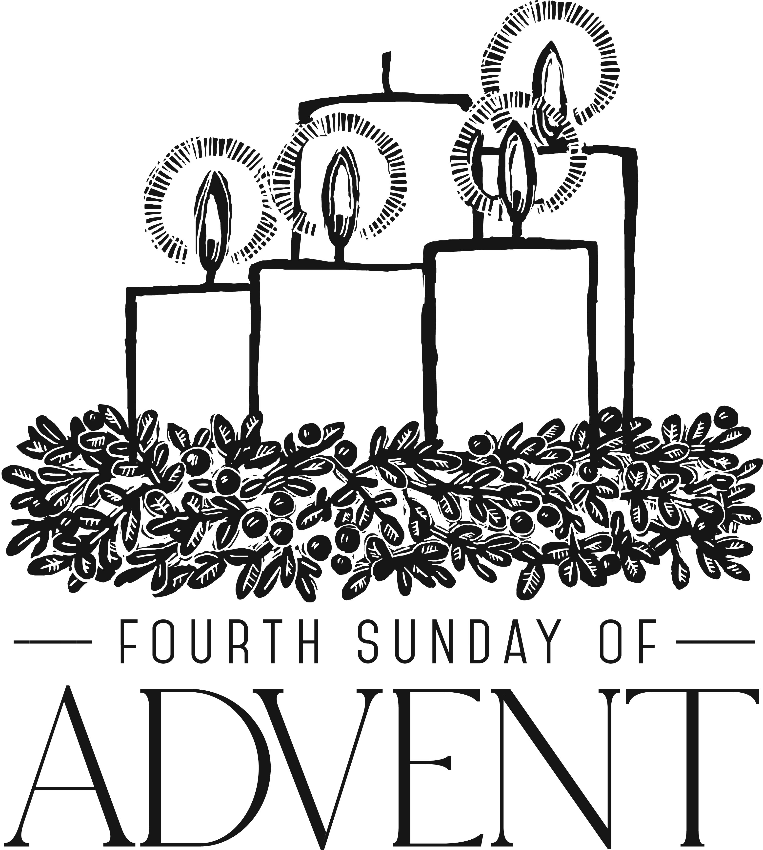

ADVENT LITURGY AND SCRIPTURE

SUNDAY SCHOOL LIGHTING OF THE BLUE LOVE CANDLE

UNISON PRAYER
O God, we thank you that Jesus showed your love for every person—babies and children, old people and young, sick people and those who were strong, rich people and those who were poor. Come to us in this Advent season, and give us love in our hearts for all people. Amen.
-2-
HYMN Come, Thou Long-Expected Jesus Verse 2 #153

CALL TO WORSHIP & PRAYER Adapted from Isaiah 7:10-16
Again, the Lord spoke to Ahaz, saying, ask a sign of the Lord your God; let it be deep as Sheol or high as heaven.
But Ahaz said, I will not ask, and I will not put the Lord to the test.
Then Isaiah said: “Hear then, O house of David! Is it too little for you to weary mortals, that you weary my God also? Therefore, the Lord himself will give you a sign.
Look, the young woman is with child and shall bear a son, and shall name him Immanuel.
He shall eat curds and honey by the time he knows how to refuse the evil and choose the good.
For before the child knows how to refuse the evil and choose the good, the land before whose two kings you are in dread will be deserted.”
Let us pray together.
Lord God, Isaiah declared there would be an end to fear and evil for God’s people in their day; now we hear your word of love for all the world today. We see and hear the children and youth spreading your light of hope, peace and joy that overcomes the weariness of our troubles. Fill us with your Spirit, we pray, as we worship you and open our hearts to your gift of love in Jesus the Savior. Amen.

*HYMN “The King of Glory Comes” #159

GOSPEL LESSON Matthew 1:18-25 pg. 1

WE HEAR GOD’S WORD THROUGH YOUTH AND CHILDREN

-3-
WE RESPOND TO GOD’S WORD

*HYMN “It Came upon the Midnight Clear” #191

PASTORAL PRAYER & UNISON LORD’S PRAYER
Our Father, who art in heaven, hallowed be thy name. Thy kingdom come; thy will be done on earth as it is in
heaven. Give us this day our daily bread, and forgive us our debts as we forgive our debtors; and lead us not into temptation, but deliver us from evil; for thine is the kingdom and the power, and the glory forever. Amen.

STEWARDSHIP INVITATION

OFFERTORY The First Noel David Paxton, Arr.

*RESPONSE “Go, Tell It on the Mountain” Vs. 3 #218
Go, tell it on the mountain, over the hills and everywhere;
go, tell it on the mountain that Jesus Christ is born.
Down in a lowly manger the humble Christ was born,
and God sent us salvation that blessed Christmas morn.
Go, tell it on the mountain, over the hills and everywhere;
go, tell it on the mountain that Jesus Christ is born.

*UNISON PRAYER OF DEDICATION
With gladness in our hearts, O God, we give our gifts. We celebrate your gifts of hope, peace, joy, and love as we open our hands to share them everywhere. Generation to generation, we join the faithful to announce that you are with us forever, as we pray in the name of Jesus, the Savior of the world. Amen.

*HYMN “As with Gladness” #236

*BENEDICTION

*POSTLUDE Festive March in D W. Rebikoff

“...and they shall name him Emmanuel,” which means, “God is with us” (Matthew 1:23, NRSV). What message is more comforting and praiseworthy? Welcome to worship.

The bulletin is given in loving memory of our parents Clyde & Dorothy Totten by Steve & Robin Totten.
-4-
The altar centerpiece is given in loving memory of her mother, Ethel Holtzscher, on her birthday, December 18th by Sandy and Jack Dawson.

If you would like to place flowers on the altar, and pick them up after church or on Monday, please call Karen Orr at (618) 558-4192. If you would like to sponsor the bulletins, please call the church office at (618) 877-6060.

Thank you to Rev. Charles Preston for serving as liturgist, to Conyr Fischer for serving as acolyte, to Rae-Ellen Vogeler for greeting, and to Chris McMillan for serving as guest organist today.

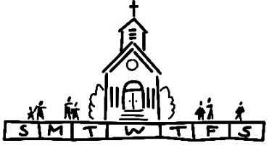
THIS WEEK
Today: Brief Special Congregational Meeting, 9:30 a.m.
In-person and Zoom Worship, 9:30 a.m.
Sunday School for Children, 9:30 a.m.
Sunday School Program, 9:30 a.m.
Fellowship Hour by Evening Guild
Confirmation - canceled
Shop With A Cop Dinner
Monday: Al-Anon, 9:30-11:00 a.m.
Tuesday: Quilters, 8:30 a.m.
Bible Study, 12:30 p.m.
Wednesday: TOPS, 9:00 a.m.
Bell Choir, 5:30 p.m.
Chancel Choir, 6:30 p.m.
Friday: OFFICE CLOSED AT NOON
Saturday: Christmas Eve Worship, 11:00 p.m.
Next Sunday: Christmas Day
In-person and Zoom Worship, 9:30 a.m.
Sunday School for Children - canceled

MISSION OF THE MONTH
Our December Mission of the Month includes the Veterans of the Cross offerings, Kindercottage, and the Layette program. Our Christmas Eve offerings are designated to the General Fund.

-5-
SHOP WITH A COP
Today, December 18th, we are hosting a luncheon in Township Hall which will service over 100 people who participate in the shop with a cop program. Thank you to those who have signed up to serve the food. If you haven’t signed up but would still like to help, you are welcome to do so. The more hands we have to help the better!

CHRISTMAS EVE & CHRISTMAS DAY SERVICES
Once again, we will keep tradition with our Christmas Eve, December 24, 10:30 p.m. music/11:00 p.m. worship service. And then, on Christmas Day, Sunday, December 25, our 9:30 a.m. worship service will repeat several traditions. Of course, both Christmas Eve and Christmas Day worship will close with candlelight “Silent Night” in German and English. What a beautiful opportunity this is to invite and bring friends and family to celebrate the birth of our Savior together and share spiritual gifts of joy!

OFFICE HOURS
The office will close at noon on December 23 and 30 and be closed December 26 and January 2. And, our secretary, Angela Potter, will take vacation days December 27, 28, 29, & 30 so please call to check if someone is in the office before coming in on those days.

OUR PRAYERS
Nursing, Assisted, & Independent Living
Earl Buenger, Marcia Buenger, Ruth Buer, Hilde Few, JoAnn King, Mary Lee Krohne, Karen Luddeke, and Leonard Schaefer.
At Home
Chloe Affolter, Isabella Boyer, Carol Braundmeier, Christopher Clark, Myra Cook, Jessie Curran, Bonnie Fornaszewski, Mary Franz, Luitgard Fries, Melba Grady, Lou Hasse, Norman Hente, Chuck King, Cindy Meyer, Sandy Mueller, Cliff Robertson, Merle Rose, Marge Schmidt, June Stille, and Nancy Wilson.
-6-
Illinois South Conference
Godfrey Evangelical UCC, Rev. Jerry (Lori) MeCaskey. Granite City St. John UCC, Rev. Karla (Rev. Charles Preston) Frost. Retired Pastor, Rev. Michael and Elizabeth Marx, Owensboro, KY.

SCRIPTURE READINGS
Matthew 1:18-25
¹⁸ Now the birth of Jesus the Messiah took place in this way. When his mother Mary had been engaged to Joseph, but before they lived together, she was found to be pregnant from the Holy Spirit. ¹⁹ Her husband Joseph, being a righteous man and unwilling to expose her to public disgrace, planned to divorce her quietly. ²⁰ But just when he had resolved to do this, an angel of the Lord appeared to him in a dream and said, “Joseph, son of David, do not be afraid to take Mary as your wife, for the child conceived in her is from the Holy Spirit. ²¹ She will bear a son, and you are to name him Jesus, for he will save his people from their sins.” ²² All this took place to fulfill what had been spoken by the Lord through the prophet: ²³ “Look, the virgin shall become pregnant and give birth to a son, and they shall name him Emmanuel,” which means, “God is with us.” ²⁴ When Joseph awoke from sleep, he did as the angel of the Lord commanded him; he took her as his wife ²⁵ but had no marital relations with her until she had given birth to a son, and he named him Jesus.

Try our QR code! This little square will take you directly to our secure MyVanco website where you can contribute to any of our various funds. Just follow three simple steps:
- Open your smart phone’s camera app
- Aim the camera at the black and white square below and a link will appear on your screen.
- Click the link and you’ll be directed to our donations website. From there, you can select a fund to which you’d like to make a contribution.

Thank you!

“Come, Thou Long-Expected Jesus”
Born thy people to deliver,
Born a child and yet a king,
Born to reign in us forever,
Now thy gracious kingdom bring.
By thine own eternal Spirit
Rule in all our hearts alone;
By thine all sufficient merit
Raise us to thy glorious throne.

“It Came upon the Midnight Clear”
It came upon the midnight clear,
That glorious song of old,
From angels bending near the earth
To touch their harps of gold;
“Peace on the earth, goodwill to all,
From heaven’s all gracious King”:
The world in solemn stillness lay
To hear the angels sing.

Still through the cloven skies they come,
With peaceful wings unfurled,
And still their heavenly music floats
O’er all the weary world;
Above its sad and lowly plains
They bend on hovering wing,
And ever o’er its Babel sounds
The blessed angels sing.

For lo, the days are hastening on,
By prophets seen of old,
When, with the ever-circling years,
Shall come the time foretold,
When peace shall over all the earth
Its ancient splendors fling,
And all the world give back the song
Which now the angels sing.

“As With Gladness”
As with gladness men of old
Did the guiding star behold;
As with joy they hailed its light,
Leading onward, beaming bright,
So, most gracious Lord, may we
Evermore your splendor see.

As with joyful steps they sped
To that lowly manger bed,
There to bend the knee before
Him whom heaven and earth adore,
So, may we with willing feet
Ever seek the mercy seat.

As they offered gifts most rare
At that manger rude and bare,
So may we with holy joy,
Pure and free from sin’s alloy,
All our costliest treasures bring,
Christ, to you, our heavenly King.

Holy Jesus, every day
Keep us in the narrow way;
And when earthly things are past,
Bring our ransomed souls at last
Where they need no star to guide,
Where no clouds thy glory hide.

“The King of Glory Comes” not printed due to copyright

