St. John United Church of Christ
“In Christ We Live, Celebrate, & Serve”

January 9, 2022 | 1st Sunday after Epiphany (C)
Rev. Karla Frost, Pastor | Ritch Alexander, Organist
9:30 Zoom & In-Person Worship | 9:30 Sunday School for Children
2901 Nameoki Road | Granite City, IL 62040
E-stjohnucc2901gc@yahoo.com | (618) 877-6060
Web-stjohnuccgranitecity.com
Currently face masks are REQUIRED for all.
Large print bulletins are available from the Ushers.
Bold italic denotes congregation reads or sings.
*Denotes all who are able, please stand.

WE COME TO WORSHIP GOD

PRE-SERVICE MUSIC, WELCOME AND ANNOUNCEMENTS

BELLS CALLING TO WORSHIP

A STORY FOR ALL GOD’S CHILDREN Isaiah 43:1-7
“Do not fear, for I have redeemed you; I have called you by name, you are mine.” Isaiah 43:1b

PRELUDE AND CENTERING OUR HEARTS ON WORSHIP
Hymn to Joy Broughton, Arr.

CALL TO WORSHIP AND PRAYER Adapted from Lighting the Flame
Well, the holidays are over. Reality has come back around.
School is somehow back in session.
Santa’s packed up and left town.
The creche is back in its box. The star is down from the tree.
The shepherds and magi returned home,
Christmas is tossed out with the tree.
But Christmas is not a day, that comes just once a year;
It’s a way of life, to be lived by all who come near,
To the manger, to the mount,
To the cross on which he died,
To the cold, empty tomb,
Where death was denied.
A life where we’re led in pastures of green,
By tables of feasting, beside streams serene.
No, Christmas is not just a day once a year,
-2-
It’s a life, a way for all those who hear,
The fluttering wings of angels on high,
The laughter of shepherds far and nigh,
The hushed awe of the kings as they kneel by the Son,
Who brings peace on earth, for each day and each
one.
Let us pray together.
Lord, we love Christmas, but we forget it all too easily. We leave behind the gift giving, the happy giggles, the warm embraces, the time taken for love. What we leave behind are the lives you want us to live every day; we leave them behind as if they’re just for the holidays. Help us not to laugh when we hear it said that Christmas is not just for Christmastime. Help us to see that that is the everyday life you intend for us, that your Christmas gift to us is fullness of life, every day of our lives. Help us to see and to live. For we may forget Christmas, but the Christ Child does not forget us. His birth proclaims a love like no other, a gift that will always be with us. Amen.

*HYMN “Come, Thou Fount of Every Blessing” #68

*RESPONSIVE PSALTER READING From Psalm 29
Ascribe to the Lord, O heavenly beings,
ascribe to the Lord glory and strength.
Ascribe to the Lord the glory of his name;
worship the Lord in holy splendor.
The voice of the Lord is over the waters;
the God of glory thunders, the Lord, over mighty waters.
The voice of the Lord is powerful;
the voice of the Lord is full of majesty.
The voice of the Lord breaks the cedars;
the Lord breaks the cedars of Lebanon.
The voice of the Lord flashes forth flames of fire.
The voice of the Lord causes the oaks to whirl,
and strips the forest bare; and in his temple all say, “Glory!”
The Lord sits enthroned over the flood;
the Lord sits enthroned as king forever.
May the Lord give strength to his people!
-3-
May the Lord bless his people with peace!

WE HEAR GOD’S WORD

NEW TESTAMENT LESSON Acts 8:12-17 pg. 118

ANTHEM I Love Thy Kingdom Lord Chancel Choir

GOSPEL LESSON Luke 3:1-3, 15-17, 21-22 pg. 56

REFLECTION

WE RESPOND TO GOD’S WORD

*HYMN “When Jesus Came to Jordan” #241

PRAYERS OF THE PEOPLE, LORD’S PRAYER & RESPONSE
Our Father, who art in heaven, hallowed be thy name. Thy kingdom come; thy will be done on earth as it is in heaven. Give us this day our daily bread, and forgive us our debts as we forgive our debtors; and lead us not into temptation, but deliver us from evil; for thine is the kingdom and the power, and the glory forever. Amen.

STEWARDSHIP INVITATION

OFFERTORY Prelude in Classical Style Young

*RESPONSE “Majesty” #43
Majesty, worship his majesty;
unto Jesus be all glory, honor, and praise.
Majesty, kingdom authority
flow from his throne unto his own, his anthem raise.
So exalt, lift up on high the name of Jesus;
magnify, come glorify Christ Jesus, the King.
Majesty, worship his majesty;
Jesus, who died, now glorified, King of all kings.

*UNISON PRAYER OF DEDICATION
Holy One, we pray that our gifts bring you glory and honor as we praise you. Through these offerings may your Word be spread near and far, so that all people may know you love them and call them by name. Bless all our ministries, as we serve in Jesus’ name. Amen.
-4-
*HYMN “Savior, Again to Your Dear Name” #711

*BENEDICTION

*POSTLUDE Trumpet Tune Purcell

Welcome to worship – each and every one of you, a chosen and beloved child of God. May we follow Jesus into the work of ministry.

The altar vases are given in celebration of the January 8th birthday of Dee Roethemeyer with Love from her Family.

If you would like to place flowers on the altar, and pick them up Monday, please call Rosalie Watson at (618) 741-2979. If you would like to sponsor the bulletins, please call the church office at 877-6060. The next available dates to sponsor bulletins are January 30 and February 6 & 27.

Thank you to Kiki Cochran for serving as liturgist today

THIS WEEK
Today: In-person and Zoom Worship, 9:30 a.m.
Sunday School for Children, 9:30 a.m.
Monday: Al-Anon, 9:30-11:00 a.m.
Brotherhood, 6:30 p.m.
Tuesday: Quilters, 8:30 a.m.
Bible Study, 12:30 p.m.
Hilltoppers, 12:30 p.m.
Wednesday: TOPS, 9:00-11:00 a.m.
Packing Food Boxes, 9:00 a.m. Youth Side
Bell Choir, 6:00 p.m.
Thursday: Council Meeting, 6:00 p.m.
Granite City Community Band Rehearsal 6:45-9:30 p.m.
Next Sunday: In-person and Zoom Worship, 9:30 a.m.
Sunday School for Children, 9:30 a.m.
Fellowship Hour Sponsored by Brotherhood

MISSION OF THE MONTH
Our January Mission of the Month is designated for UCC Disaster Ministries. Donations will be used to provide housing, food and meals, and family needs for those who were affected by the storms that caused devastation in parts of the Midwest on December 10, 2021

JANUARY FOOD BOXES
The time has come to pack the food boxes, which will be distributed to the public on January 22. If you are able to help, we will be packing
-5-
175 boxes this Wednesday, January 12 at 9:00 a.m. on the youth side. Your help will be greatly appreciated. Masks will be required.

GIRL SCOUT COOKIES
If you’d like to order Girl Scout cookies, Eleanor and Allison Reynolds will be selling them today after church.

OUR PRAYERS
Nursing & Assisted Living
Ruth Buer, Hilde Few, Carol Hildebrand, JoAnn King, Mary Lee Krohne, and Karen Luddeke.
Hospital
David Oliver Jr. is at Christian Hospital.
At Home
Ritch Alexander, Isabella Boyer, Bobbie Braden, Marlene Brokaw, Myra Cook, Randy Fischer, Bonnie Fornaszewski, Mary Franz, Luitgard Fries, Lou Hasse, Norman Hente, Gayle Lindsay, Bill McAmish, Sandy Mueller, Cliff Robertson, Merle Rose, Marge Schmidt, June Stille, Trish Stromlund, Janice Weeks, and Don Young.
Illinois South Conference
Columbia St. Paul UCC, Rev. Elizabeth Terrill, Interim Pastor. New Baden Zion UCC, Rev. Stephen (Molly) Stark. Retired Pastor, Rev. Diane Grohmann, New Athens, IL.

SCRIPTURE READINGS
Acts 8:12-17
¹² But when they believed Philip, who was proclaiming the good news about the kingdom of God and the name of Jesus Christ, they were baptized, both men and women. ¹³ Even Simon himself believed. After being baptized, he stayed constantly with Philip and was amazed when he saw the signs and great miracles that took place. ¹⁴ Now when the apostles at Jerusalem heard that Samaria had accepted the word of God, they sent Peter and John to them. ¹⁵ The two went down and prayed for them that they might receive the Holy Spirit ¹⁶ (for as yet the Spirit had not come upon any of them; they had only been baptized in the name of the Lord Jesus). ¹⁷ Then Peter and John laid their hands on them, and they received the Holy Spirit.

-6-
Luke 3:1-3, 15-17, 21-22
In the fifteenth year of the reign of Emperor Tiberius, when Pontius Pilate was governor of Judea, and Herod was ruler of Galilee, and his brother Philip ruler of the region of Ituraea and Trachonitis, and Lysanias ruler of Abilene, ² during the high priesthood of Annas and Caiaphas, the word of God came to John son of Zechariah in the wilderness. ³ He went into all the region around the Jordan, proclaiming a baptism of repentance for the forgiveness of sins,
¹⁵ As the people were filled with expectation, and all were questioning in their hearts concerning John, whether he might be the Messiah, ¹⁶ John answered all of them by saying, “I baptize you with water; but one who is more powerful than I is coming; I am not worthy to untie the thong of his sandals. He will baptize you with the Holy Spirit and fire. ¹⁷ His winnowing fork is in his hand, to clear his threshing floor and to gather the wheat into his granary; but the chaff he will burn with unquenchable fire.”
²¹ Now when all the people were baptized, and when Jesus also had been baptized and was praying, the heaven was opened, ²² and the Holy Spirit descended upon him in bodily form like a dove. And a voice came from heaven, “You are my Son, the Beloved; with you I am well pleased.”

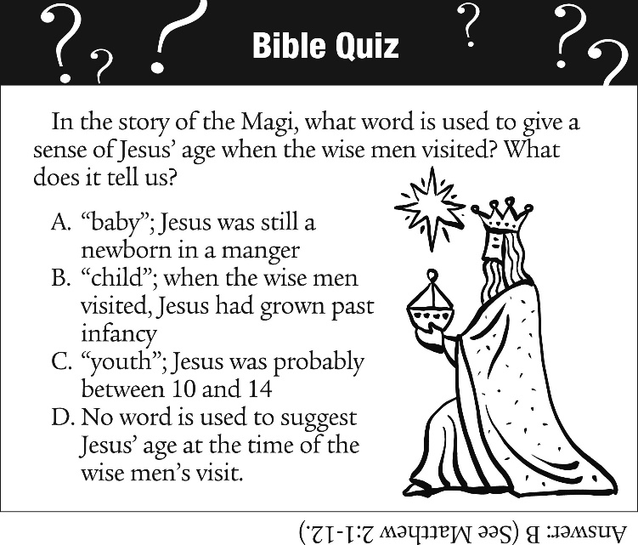

“Come, Thou Fount of Every Blessing”
Come, thou Fount of every blessing,
Tune my heart to sing thy grace;
Streams of mercy, never ceasing,
Call for songs of loudest praise.
Teach me some melodious sonnet,
Sung by flaming tongues above;
Praise his name – I’m fixed upon it –
Name of God’s redeeming love.

Here I raise to thee an altar,
Hither by thy help I’ve come;
And I hope, by thy good pleasure,
Safely to arrive at home.
Jesus sought me when a stranger,
Wandering from the fold of God;
He, to rescue me from danger,
Bought me with his precious blood.

O to grace how great a debtor
Daily I’m constrained to be!
Let thy goodness, like a fetter,
Bind my wandering heart to thee;
Prone to wander, Lord, I feel it,
Prone to leave the God I love;
Here’s my heart, O, take and seal it;
Seal it for thy courts above.

“When Jesus Came to Jordan”
Words: Fred Pratt Green; para. Matthew 3:13-17, Mark 1:9-11, Luke 3:21-22 © 1980 Hope Publishing Company. Reprinted by permission, CCLI License #1334401.
When Jesus came to Jordan
To be baptized by John,
He did not come for pardon
But as the sinless one.
He came to share repentance
With all who mourn their sins,
To speak the vital sentence
With which good news begins.

He came to share temptation,
Our utmost woe and loss,
For us and our salvation
To die upon the cross.
So when the dove descended
On him, the Son of Man,
The hidden years had ended,
The age of grace began.

Come, Holy Spirit, aid us
To keep the vows we make;
This very day invade us,
And every bondage break.
Come, give our lives direction,
The gift we covet most:
To share the resurrection
That leads to Pentecost.

“Savior, Again to Your Dear Name”
Savior, again to your dear name we raise
With one accord our parting hymn of praise;
We give you thanks before our worship cease,
And now departing, wait your word of peace.

Grant us your peace upon our homeward way;
With you began, with you shall end the day;
Guard now the lips from sin, the hearts from shame,
That in this house have called upon your name.

Grant us your peace, Lord, through the coming night;
Turn all our darkness to your perfect light;
Then, while we sleep, our hope and strength renew,
For dark and light are both alike to you.

Grant us your peace throughout our earthly life:
Comfort in sorrow, courage in the strife;
Then, when your voice shall make our conflict cease,
Call us, O Lord, to your eternal peace.

