St. John United Church of Christ
“In Christ We Live, Celebrate, & Serve”

April 4, 2021 Easter Sunday
Pastor: Karla J. Frost Organist: Ritch Alexander
9:30 Worship & Sunday School (618) 877-6060
2901 Nameoki Rd. Granite City, IL 62040 E-stjohnucc2901gc@yahoo.com Web-stjohnuccgranitecity.com

To follow safety guidelines, please keep social distance, mask up, speak softly, and no congregational singing.

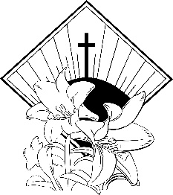

WE COME TO WORSHIP GOD

PRE-SERVICE MUSIC

WELCOME AND ANNOUNCEMENTS

BELLS CALLING TO WORSHIP

A STORY FOR ALL GOD’S CHILDREN Psalm 118:1-2, 14-24
O give thanks to the Lord, for he is good; his steadfast love endures forever! ...This is the day that the Lord has made; let us rejoice and be glad in it. (Psalm 118:1, 24)

PRELUDE AND CENTERING OUR HEARTS ON WORSHIP
“Christ the Lord Is Risen Today” Williams

CALL TO WORSHIP & PRAYER
Easter begins in despair.
Our life, our love, our hope forever dead,
Stricken by violence, stone locked in a cave.
Who will roll away the stone?
Easter takes us by surprise, early in the morning.
The obstacles we expect to face are removed.
Where once death and despair laid locked in time
-2-
now the bright light of hope sprouts wings to fly from emptiness.
It is, at first, too good to be true.
Where have you laid him?
When faced with a miracle, our first reflex is to run.
Be not afraid.
Jesus names us and takes away our fear.
Go and tell.
Suddenly the realization dawns. It may rise as quietly as the sun creeping over the horizon, or it may explode like fireworks, painting the world with dazzle. We recognize the One who was dead as he is alive for us.
Alleluia! Christ is risen, risen indeed!
Let us pray together:
Giver of new life, we come this morning with our alleluias, our flowers, and our stirring music. We come to worship in beauty and in truth, because we have faith that Jesus Christ is raised from the dead, because we have hope that the resurrection will enter into each of our lives and transform them, and because, through Christ’s Spirit, we have love and joy to share. Receive our worship, gracious God. Be present with us as miracle and mystery, and as the voice of peace calling each of us by name. Amen.

HYMN “Christ the Lord Is Risen Today”
Christ the Lord is risen today, Alleluia!
All creation, join to say Alleluia!
Raise your joys and triumphs high, Alleluia!
Sing, ye heavens, and earth reply, Alleluia!

Love’s redeeming work is done, Alleluia!
Fought the fight, the battle won, Alleluia!
Death in vain forbids him rise, Alleluia!
Christ has opened paradise. Alleluia!

Lives again our glorious King, Alleluia!
Where, O death, is now thy sting? Alleluia!
Once he died our souls to save, Alleluia!
Where thy victory, O grave? Alleluia!
-3-
Soar we now where Christ has led, Alleluia!
Following our exalted Head, Alleluia!
Made like him, like him we rise, Alleluia!
Ours the cross, the grave, the skies. Alleluia!

LITANY OF CONFESSION AND PARDON
Powerful and loving God, you have raised Jesus Christ from the dead; raise us too as we open our lives to you.
May distrust and self-hatred, which keep us from loving, be broken away so that new life can emerge.
May new community spring up, where fear has kept us from the stranger or seeker.
May impatience and judgmentalism, which prevent us from caring and compassion, be rolled out of the way.
May trust and peace blossom, where injustice and conflict have divided us from one another.
Breathe new life into us, we pray, so we may greet the Lord with joy. Amen.
God is wise and knows our doubts, our fears, and our failures, which we bring to the tomb on Easter morning. In the light of this new day, the Spirit brightens our hope, courage and faith. We are forgiven!
We live to praise and serve, in the name of Jesus Christ!

WE HEAR GOD’S WORD

NEW TESTAMENT READING Acts 10:34-41

DUET Come with Rejoicing Roni Douglas & Becky Kriegel

GOSPEL READING John 20:1-18

REFLECTION

WE RESPOND TO GOD’S WORD

HYMN “The Day of Resurrection!” Verses 1 & 3
The day of resurrection! Earth, tell it out abroad,
the Passover of gladness, the Passover of God.
From death to life eternal, from sin’s dominion free,
our Christ has brought us over with hymns of victory.
-4-
Now let the heavens be joyful! Let earth its song begin!
The world resound in triumph, and all that is there-in;
let all things seen and unseen their notes of gladness blend; for Christ the Lord has risen, our Joy that has no end.

PASTORAL PRAYER AND THE LORD’S PRAYER
Our Father, who art in heaven, hallowed be thy name. Thy kingdom come; thy will be done on earth as it is in heaven. Give us this day our daily bread, and forgive us our debts as we forgive our debtors; and lead us not into temptation, but deliver us from evil; for thine is the kingdom and the power, and the glory forever. Amen.

THE SACRAMENT OF HOLY COMMUNION

STEWARDSHIP INVITATION & BLESSING PRAYER
We thank you, Lord, for uniting your people in every place and time to praise and serve you. May our gifts carry the Good News of resurrection joy everywhere. Amen.

RESPONSE Chime Response

INVITATION AND COMMUNION PRAYER

PREPARING AND SHARING THE ELEMENTS
(All confessing Christians are invited to partake from the Table of the Lord)

UNISON PRAYER OF THANKSGIVING
We thank you, Eternal God, for the glorious truth that you bring hope out of despair, resurrection out of death, and peace out of brokenness. In this Sacrament we have received the risen presence of Christ into our hearts and lives. Joyfully, we now go to share the good news! Amen.

HYMN “Thine Is the Glory”
Thine is the glory, risen, conquering Son;
endless is the victory thou o’er death hast won.
Angels in bright raiment rolled the stone away,
kept the folded graveclothes where thy body lay.
Thine is the glory, risen, conquering Son;
endless is the victory thou o’er death hast won.
-5-
Lo! Jesus meets us, risen from the tomb;
lovingly he greets us, scatters fear and gloom.
Let his church with gladness hymns of triumph sing,
for her Lord now liveth; death hath lost its sting.
Thine is the glory, risen, conquering Son;
endless is the victory thou o’er death hast won.

No more we doubt thee, glorious Prince of life!
Life is nought without thee: aid us in our strife.
Make us more than conquerors, through thy deathless love: bring us safe through Jordan to thy home above.
Thine is the glory, risen, conquering Son;
endless is the victory thou o’er death hast won.

BENEDICTION

POSTLUDE “Hallelujah” Handel

Call to Worship & Prayer and Litany of Confession and Pardon, adapted and reprinted by permission of the publishers from Touch Holiness, ed. Ruth C. Duck and Maren C,. Tirabassi. © 1990 by The Pilgrim Press.

Christ is risen! Alleluia! Welcome to worship – and to resurrection life – on this most joyous day.

The bulletins are given in loving memory of our parents Thelma and Rich Suess and Rose and Robert Douglas, by Veronica and Dave Douglas.

The New Christ Candle is given in loving memory of their parents, Alvin Henry Willaredt and Margaret Willaredt Rush, and their sisters, Jackie Willaredt and Cheryl Prough by Steve Willaredt and family.

If you would like to place flowers on the altar, and pick them up Monday, please call Sue Goedeke at (618) 791-0137. If you would like to sponsor the bulletins, please call the church office at 877-6060. The next available dates are April 25, and May 2, 16, & 30.

-6-
Sunday School for children in the classroom by the nursery has resumed. Everyone enters through the elevator entrance and follows all Covid19 procedures, including wearing masks at all times. No snacks are offered. Older youth are encouraged to attend worship in the Sanctuary or on Zoom.

Our special Easter offering envelope giving will be placed in the General Fund to support our ministries at St. John UCC.

THIS WEEK
Today: Sunday School for Pre-registered Children
In-person and Zoom Worship 9:30 a.m.
Outdoor Service 11:00 a.m.
Monday: Al-Anon 9:30-11:00 a.m.
Tuesday: Quilters, 8:30 a.m.
Zoom Bible Study, 3:00 p.m.
Voting Day
Wednesday: Cemetery Meeting, 5:00 p.m.
Thursday: Zoom Council Meeting, 6:00 p.m.
Next Sunday: Sunday School for Children
In-person and Zoom Worship 9:30 a.m.

OUR PRAYERS
Nursing and Assisted Living
Ruth Buer, Loretta Cook, Hilde Few, Bonnie Fornaszewski, JoAnn King, Mary Lee Krohne, and Karen Luddeke.
At Home
Ritch Alexander, Rose Marie Bauer, Isabella Boyer, Paul Boyer, Marlene Brokaw, Myra Cook, Randy Fischer, Mary Franz, Norman Hente, Bill McAmish, Billie Meyer, Sandy Mueller, Cliff Robertson, Merle Rose, Leroy Schaefer, Valara Schorfheide, Marge Schmidt, June Stille, and Don Young.
Illinois South Conference
Carlyle Immanuel UCC, Pastor Ken (Barbara) Schafer, Central City Zion UCC, Rev. Nancy Peebles, Retired Pastor Rev. Robert Schmidt, Sherman, IL
-7-
We extend our Christian sympathy to the family of Nadine Ryan, who passed from this life on Monday, March 29, 2021. A funeral service was held on Thursday, April 1, 2021. May the peace and comfort that come from God sustain her loved ones during this time of grief.

We extend our Christian sympathy to the family of Christine “Christy” Dawson, who passed from this life on Wednesday, March 31, 2021. A private funeral service will be held on Wednesday, April 7, 2021. May the peace and comfort that come from God sustain her loved ones during this time of grief.

SCRIPTURE READINGS
Acts 10:34-41
³⁴ Then Peter began to speak to them: “I truly understand that God shows no partiality, ³⁵ but in every nation anyone who fears him and does what is right is acceptable to him. ³⁶ You know the message he sent to the people of Israel, preaching peace by Jesus Christ—he is Lord of all. ³⁷ That message spread throughout Judea, beginning in Galilee after the baptism that John announced: ³⁸ how God anointed Jesus of Nazareth with the Holy Spirit and with power; how he went about doing good and healing all who were oppressed by the devil, for God was with him. ³⁹ We are witnesses to all that he did both in Judea and in Jerusalem. They put him to death by hanging him on a tree; ⁴⁰ but God raised him on the third day and allowed him to appear, ⁴¹ not to all the people but to us who were chosen by God as witnesses, and who ate and drank with him after he rose from the dead.

John 20:1-18
Early on the first day of the week, while it was still dark, Mary Magdalene came to the tomb and saw that the stone had been
removed from the tomb. ² So she ran and went to Simon Peter and the other disciple, the one whom Jesus loved, and said to them, “They have taken the Lord out of the tomb, and we do not know where they have laid him.” ³ Then Peter and the other disciple set out and went toward

-8-
the tomb. ⁴ The two were running together, but the other disciple outran Peter and reached the tomb first. ⁵ He bent down to look in and
saw the linen wrappings lying there, but he did not go in. ⁶ Then Simon Peter came, following him, and went into the tomb. He saw the linen wrappings lying there, ⁷ and the cloth that had been on Jesus’ head, not lying with the linen wrappings but rolled up in a place by itself. ⁸ Then the other disciple, who reached the tomb first, also went in, and he saw and believed; ⁹ for as yet they did not understand the scripture, that he must rise from the dead. ¹⁰ Then the disciples returned to their homes.

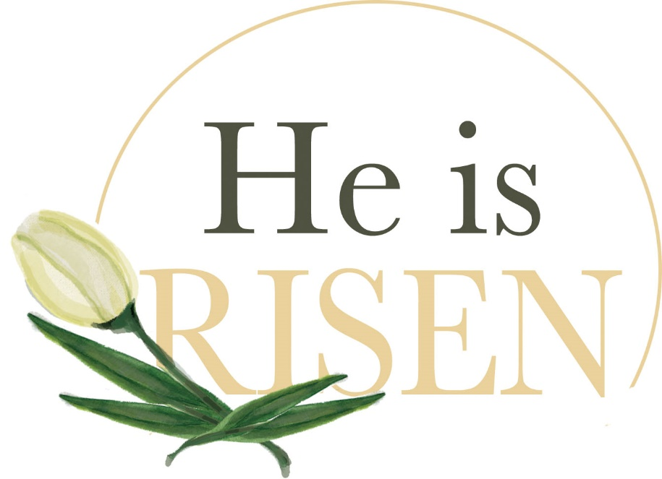

-9-
We express a deep word of appreciation to everyone who has given a lily for the sanctuary this morning. Your contributions have added to the beauty of our Easter Celebration. Donors are invited to take a lily home after the service or to pick one up on Tuesday. Also, we give a special thank you to the Altar Guild for decorating everything so beautifully.

IN HONOR OF Karen Frost
By Revs. Karla Frost and Charles Preston
IN HONOR OF All the Springtime beauty!
By Beverly and Scott Meyer
IN GRATITUDE FOR our “little” Douglas Family, Josh, Acacia, Milo and Charlie
By David and Veronica Douglas
IN GRATITUDE FOR Honey and Horace
By Revs. Karla Frost and Charles Preston
IN GRATITUDE FOR All of our friends and Church Family
By Chuck and Lou Hasse
IN GRATITUDE FOR the love and support of my children and their families
By Joyce Valbert
IN CELEBRATION for the life of our brother, Steven Suess
By David and Veronica Douglas
IN CELEBRATION of New Beginnings, for a Hopeful 2021
By Robert and Joan Mueller
REMEMBERING beautiful Easters together with our Emily Anne
By David and Veronica Douglas
IN LOVING MEMORY OF our parents, Richard and Thelma Suess and Robert and Rose Douglas
By David and Veronica Douglas
IN LOVING MEMORY OF Royal and Helen Preston and Ken Frost and Janet Frost
By Revs. Karla Frost and Charles Preston

-10-
IN LOVING MEMORY OF Departed Friends and Family
By Chuck and Lou Hasse
IN LOVING MEMORY OF Otis and Lois Hollenbeck
By their Grandchildren and Great Grandchildren
IN LOVING MEMORY OF our friend, Dick Oliver
By The Kriegel Family
IN LOVING MEMORY OF our friend, Murial Kratz
By The Kriegel Family
IN LOVING MEMORY OF Dear, Departed Loved Ones
By The Kriegel Family
IN LOVING MEMORY OF My Parents Bob and Wilma Jacobs
By Bob and Nancy Jacobs
IN LOVING MEMORY OF William D. Mees
By Hedy Mees
IN LOVING MEMORY OF Ervin and Eva Mueller, Ervin H. Mueller
By Robert and Joan Mueller
IN LOVING MEMORY OF all my departed loved ones
By Karen Orr
IN LOVING MEMORY OF Wallace and George Roethemeyer
By Dee Roethemeyer
IN LOVING MEMORY OF departed loved ones
By Jennifer Sage
IN LOVING MEMORY OF Raymond and Jane Lux and Ed and Della Seibold
By Mike and MaryJo Seibold
IN LOVING MEMORY OF Family and Friends
By Mike and MaryJo Seibold
IN LOVING MEMORY OF my husband, parents, sisters, and brother – all dearly loved and sadly missed
Joyce Valbert

